COMPARISON OF MARTIAN DUST DEVIL TRACK MORPHOLOGIES IN GUSEV AND RUSSELL CRATERS
By Circe Verba

A Thesis
Submitted in Partial Fulfillment
of the Requirements for the Degree of
Master of Science
in Geology

Northern Arizona University
May 2009

Approved:
___________________________
Paul Geissler, Ph.D., Chair

___________________________
Ron Blakey, Ph.D., Co-Chair

___________________________
Nadine Barlow, Ph.D.

___________________________
Diana Anderson, Ph.D.

ABSTRACT
COMPARISON OF MARTIAN DUST DEVIL TRACK MORPHOLOGIES IN GUSEV AND RUSSELL CRATERS

CIRCE VERBA

Convective vortices, known as dust devils, entrain material and leave behind dark trails on the surface of the Martian landscape. These tracks are a result of dust devils exposing the darker substrate from the dust-mantled surface as it entrains dust. Occurring during peak local insolation, dust devils are an observable subset of the myriad atmospheric vortices of wind that comprise boundary layer turbulence above a heated surface.
Detailed HiRISE images were used to observe the seasonal changes of dust devil tracks in Gusev and Russell craters, focusing on the temporal and morphological differences between the two locations. Seasonal variations in dust devil activity are influenced by topography, sediment supply, and elevation, as well as latitudinal variations in the atmospheric dust cycle and local winds.
Topographical features, such as the dunes in Russell, enhance convective circulation, thereby playing a key role in dust devil formation. The greater the contrast between surface and air temperatures, the greater the surface heat flux and potential for dust devil activity. The NASA Ames Mars General Circulation Model (GCM) was used to compare predicted wind directions and magnitudes to tracks mapped from inferred scallops using ESRI’s ArcMap program.
Observations indicate distinct variations in the density, shape, and size of the tracks as the season progress. Russell crater tracks are curvilinear and highly sinuous, with widths and lengths ranging from 20 to 40 m and 340 m to 9 km respectively. Gusev crater tracks are less sinuous, measuring tens of meters wide and 2 to 4 km long. Dust devil tracks follow a general wind trend indicating that track lengths are a proxy for local wind speeds.
The active dust devil season in Gusev crater is much shorter (L_{S}= 139º - 12º) than that of Russell crater (L_{S}= 172º - 40º). Peak dust devil frequencies occur earlier and more consistently at Gusev (L_{S} 250º) and are more variable at Russell crater (L_{S} 316º). Possible explanations for the differences in seasonal behavior between the study sites include: (1) average elevations up to 2000 m higher at Russell crater than at Gusev, resulting in enhanced convective circulation (due to lower atmospheric density, with a similar solar energy input; (2) increased insolation at higher southern latitudes during perihelion; and (3) frost on the dunes both delays and ends the dust devil season in Russell crater.
There is a correlation between track features (frequency, lengths, and widths) and temperature shown by examination of Thermal Emission Spectrometer (TES) measurements of near surface atmospheric temperatures at pressures of 6.1 mb (Gusev) and 4.75 mb (Russell). During the greatest period of thermal contrast, dust devils reached maximum potential; during periods of thermal inversion dust devils were absent.
The mechanism of track erasure is influenced by events other than gradual atmospheric airfall sedimentation; episodic erasure by dust storms, overprinting by fresh dust devils, surface frost, and change in winter winds are the major contributions of track erasure.
Acknowledgements
This project has allowed me to meet many incredible people from banging on office doors to attending scientific meetings. I would first like to thank my mother, Karen Verba, for feeding my fascination of the planets, which helped me to become the first member of my family to earn a Master’s degree. Secondly, my sister, Dionne for attempting to read my short-sentenced, science jargon and be a listening ear. I would also like to thank my undergraduate best friend, Sarah Baxter, and my best friend as a graduate student, Beth Barton, for helping me get through difficult times, and for the emotional support, camaraderie, as well as entertainment they provided.
I’d also like to thank Cynthia Phillips at SETI Institute for accepting me for my first Mars science research internship in 2006 and prompting my interest in research. Most importantly, the person that has now made a significant impact on my life is Paul Geissler, my advisor and close friend at the U.S. Geological Survey. Thank you, Paul, for seeing what I could be and the potential inside my excited eyes (plus dealing with the tears and frustration). Finally, I’d like to thank my undergraduate assistant Colleen Watling for processing MOC images for me.
Others I’d like to thank by name: Diana Anderson, Ron Blakey, Nadine Barlow (my committee members), and Carin Cornwall, Glen Cushing, Corey Fortezzo, Rose Hayward, Ken Herkenhoff, Hanna Latela, Ramses Ramirez, Tim Titus, Devin Waller, & the HiRISE Team for help with TES data and modeling, GIS help, thermodynamics of dust devil comprehension, and MER Spirit’s observations.
The technical support at the USGS has also been a great help through the epic battle of image processing.
Table of Contents
Abstract…………………………………...……………………………………..page ii
Acknowledgements ………………………………………………………….....page iv
Table of Contents………………………………………………………………..page v
List of Tables………………………………………………………………..….page vii
List of Figures……………………………………………………….…...……page viii
Chapter 1
Introduction ………………………………………………………..…..page 1
Geologic Settings: Gusev and Russell craters .…………………..…….page 6
Background ……………………………………………….……….…..page 8
Chapter 2: Thermodynamical Theory
Formation of dust devils………………...………………….…………..page 12
Basic movement ……………………..…………….…………………. page 20
Chapter 3: Methods
Image Processing ………………..…..…….……………….…. page 22
Using ESRI’s ArcMap & ArcScene..………………………..... page 28
Global Climate Model………...………….….….….…. page 30
Russell Crater Dunes Digital Elevation Model ....……. page 30
Chapter 4: Results
Detailed Image Analysis………………….………………..…. page 33
Image specifics for Gusev crater…….………………....page 33
Image specifics for Russell crater………………….…. page 34
Results Summary (Comparison) ………………….……….…. page 37
MOC Observations…………………………………..…page 46
Chapter 5: Interpretation
Formation of dust devil tracks ……………………..……..………..…. page 47 Temperature Correlation …………………..….....…………… page 47
Gusev crater ……………………………………………page 47
Russell crater ……………………………...………...…page 53
Correlation Analysis ……………………....………..….page 58
Tangential Wind Velocity and Dust Devil Duration ..……..…. page 58
Erasure of dust devil tracks …….…….……….......….………. page 60
Settling Rates Compared to Observational HiRISE erasure….. page 63
Chapter 6: Discussion
Why are the two sites different? ..…………………………………...…page 65
Elevation, Latitude, & Topography ……………….………...... page 66
Sediment supply…………………………………………..…... page 67
Influence of CO₂ frost…………………….…………..………. page 68 Cold Spot Activity …………………..………..………. page 70
Conclusions
Summary…. ……………………..…………….….….………………. page 73
Future work ……………………..…………….…...…………………. page 76
References ……………………..…………….………….….…...……………. page 77
Table Appendix ……………………..……………………......………………. page 81
Image Appendix (digital format)
Gusev crater
Russell crater
ArcMap Metadata: GCM & Mapping (tracks) files

List of Tables
Table 1: Detailed descriptions of dust devil activity in each HiRISE image in Gusev and Russell craters……………………………………………………...… pages 33-36
1A: Gusev crater HiRISE image specifics……...………...……………page 33
1B: Russell crater HiRISE image specifics………………...…………. page 34

Table 2: The erasure time scale for dust devil tracks seen in HiRISE image pairs…………………………………………………………………………… page 63

Table 3: Gusev crater HiRISE data specifics……………………...………….. page 81

Table 4: Russell crater HiRISE data specifics………………………………… page 82

Table 5: Gusev crater MOC data specifics...………………………...………... page 83

Table 6: Russell crater MOC data specifics…………………………..………. page 84

List of Figures
Figure 1: Martian dust devil spotted by Spirit (Gusev crater) that has a plume, dust column, and small dust skirt (rarely seen) …..………………………….………page 2

Figure 2: HiRISE PSP_004249_1255_IRB: Dust devil tracks in Russell crater.
The tracks are the result of removing the dust-mantled bright surface, revealing the darker substrate. Track types: linear, curved, and irregular morphologies. The Martian dust devil tracks generally vary from 10 m to greater than 200 m in width, and can range up to a few kilometers in length (Edgett and Malin, 2000; Balme et al., 2003; Fisher et al., 2005)…………………………………………………………….. page 3

Figure 3: Mars Orbiter Laser Altimeter (MOLA) data from the Mars Global Surveyor (MGS) spacecraft depicting a global topographic map. A) Gusev crater (14.6ºS, 175.4ºE) & B) Russell crater (53.3ºS, 12.9ºE)………………………...……… page 5

Figure 4: Two views of a 3D image created from the Russell DEM in ArcScene with a 1.5 vertical exaggeration. Tier 1 dunes have a height of ~580 m with a slope angle of 17.13º between transverse dunes and slopes, versus tier 2 dunes at an angle of 10.6º, a height of ~200 m for the tier 2 linear/reverse dunes…………..……… page 7

Figure 5: HiRISE PSP_003834_1650 Columbia Hills region A) Before image. B) Close up of PSP_003834_1650 that depicts a dust devil leaving a trail (indicated by arrow and red square)……………………………………………….………….. page 9

Figure 6: Dust devil changes in Russell crater A-B) Dunes are covered in CO₂ frost early in the spring season; sinuous track morphology is evident as the surface begins to defrost. C-D) Increase of dust devil activity with decrease of surface albedo. E-F) Tracks are covered as dust is deposited and the dune ridges begin to frost over ………………………………………………………………………………… page 24

Figure 7 : Changes in Gusev crater: A) Slow increase in dust devil activity; B) Large increase of activity; C) 2007 dust storm erases tracks; D) Increase of dust devil activity after dust storm; E-F) No erasure or dust deposition to end of season................................................................................................................. page 25

Figure 8: Image processing and modification in ISIS3 Qview; and viewing JP2000 full scale of gullies and albedo boundaries of the dust devil tracks in IAS Viewer………………………………………………………………………… page 27

Figure 9: Image and diagram of an experiment run with the Arizona State University Vortex Generator, an apparatus used to simulate dust devils. Overlapping scallops determines direction dust devil is moving. (Malin and Edgett, 2001; Greeley et al., 2004)…………………………………………………………………………... page 28

Figure 10: Colored elevation DEM of Russell crater overprinted on PSP_001981_1255 to create 3D image of the Russell dunes. Color gradient relative to elevation height: Red (highest) to light blue (lowest)………………………… page 32

Figure 11: Examples of Russell dunes of directional mapping procedure based on dust devil scallops in PSP_002548_1255 and PSP_005383_1255………………… page 38

Figure 12: GCM (model) predictions of wind orientation and strength in Gusev and Russell craters. The measured orientations of the dust devil tracks match well with modeled peak lower atmospheric winds……………………...………………. page 39

Figure 13: Density of dust devil tracks in each image in Gusev and Russell craters; used to determine the peak season and season length ………………………... page 42

Figure 14: Lengths of tracks in each image of Gusev and Russell craters……. page 43

Figure 15: Widths of tracks in each image of Gusev and Russell craters…….. page 44

Figure 16: Track sinuosity in each image of Gusev and Russell craters……… page 45

Figure 17: Profile of fractional coverage (density) of dust devil tracks in Gusev crater compared to 1999-2001 TES measurements of the surface to atmosphere temperature contrast with season. Atmospheric temperatures at pressures of 6.1 mb, 4.75 mb, 2.24 mb, 1.06 mb, 0.5 mb, and 0.11 mb were used…..…………………………….. page 49

Figure 18: Profile of dust devil track lengths in Gusev crater compared to the surface and atmospheric temperature contrast with season…………………………… page 50

Figure 19: Profile of dust devil track widths in Gusev crater compared to the surface and atmospheric temperature contrast with season…………………………… page 51

Figure 20: Profile of lengths (red), width (gold), and fractional coverage (blue) in Gusev crater compared to the surface and atmospheric temperature contrast with season…………………………………………………………………….…… page 52

Figure 21: Profile of fractional coverage (density) in Russell crater compared to the surface and atmospheric temperature contrast with season. Atmospheric temperatures at pressures of 4.75 mb, 3.7 mb, 2.24 mb, 1.06 mb, 0.5 mb, and 0.11 mb.…... page 54

Figure 22: Profile of dust devil track lengths in Russell crater compared to the surface and atmospheric temperature contrast with season…………………………… page 55

Figure 23: Profile of dust devil track widths in Russell crater compared to the surface and atmospheric temperature contrast with season…………………………… page 56

Figure 24: Profile of lengths (gold), width (red), and fractional coverage (blue) in Russell crater compared to the surface and atmospheric temperature contrast with season. A temperature inversion during periods of CO₂ surface frost results in no dust devil activity…………………………………………………………………... page 57

Figure 25: Cold spot activity (2003 TES data) profile based on season and latitude. There is no cold spot present at Russell crater (54ºS, 12.5ºE) although there is indication of cold spot activity nearby (crosses indicate cold spot activity, the majority of cold spots form within the polar night, represented by the solid line). Courtesy of Cornwall & Titus (2009)………………………………………… page 72
Chapter 1
Introduction
Martian dust devils were first discovered in 1976 in Viking images, and confirmed by Mars Orbiter Camera (MOC) images (Thomas & Gierasch, 1985; Grant & Schultz, 1987; Edgett and Malin, 2000). NASA's Mars Reconnaissance Orbiter (MRO) carries cameras, spectrometers and radar to study Mars' daily activity. MRO hosts the High Resolution Imaging Science Experiment (HiRISE) camera which has provided the resolution required to examine very fine detail, up to 25-30 cm/pixel, of the Martian surface, including dust devils tracks.
Martian dust devils are vortices that form when warm air rising from solar-warmed surfaces is replaced by colder dense air lifts particles with a suction effect inside a low-pressure convection core (Sinclair, 1969; Renno et al., 1998; Greeley et al., 2003). Dust devils absorb heat as warm air parcels spiral horizontally toward the center until they reach the dust column, which forces the air upward (Renno et al., 1998). Sinclair (1969) stated that dust devils form as a result of a vertical instability in the atmosphere, and are initiated by a thermal updraft that develops into a vortex with a supply of material. The dust transport also responds to changes with wind stress, rotating wind speeds, and atmospheric mixing (Newman et al., 2002; Balme and Greeley, 2005). Dust devils become visible when they begin to entrain dust particles into the core of the vortex (Greeley et al., 2006). Chapter 2 describes the theoretical framework to understand the mechanisms that produce a dust devil and the factors behind dust devil characteristics.
Greeley et al. (2006) divided the size of particles carried by dust devils into three categories: granules transported by surface creep (grain sizes 2,000-4,000 μm in diameter), sand grains moved by saltation (grain sizes of 62-2,000 μm in diameter), and fine grained dust carried by suspension (grain sizes less than 62 μm in diameter). Based on Mars Exploration Rover (MER) Spirit observations (figure 1), Greeley (2006) concluded that the majority of Martian dust devils lack a dust “skirt” that terrestrial dust devil appear to have.

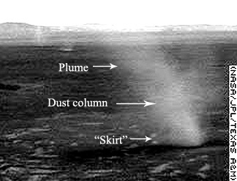

Figure 1: Martian dust devil spotted by Spirit in Gusev crater that has a plume, dust column, and small dust skirt (rarely seen) as a result of material being thrown out.

A dust devil skirt forms when the heavier, sandy material is ejected out of the dust devil because it cannot be uplifted into the vortex. It is thought that on Mars, only smaller particles are picked up off the surface, or that the heavier material is not accessible (under a cemented dust mantle).
As dust devils remove material from the surface, the dark tracks left behind appear as linear, curved, and irregular morphologies (figure 2). The Martian dust devil tracks generally vary from 10 m to greater than 200 m in width, and can range up to a few kilometers in length (Edgett and Malin, 2000; Balme et al., 2003; Fisher et al., 2005). Many tracks cross-print one another or completely erase previous tracks. The tracks are the result of removing the dust-mantled bright surface, revealing the darker substrate. The dark surface albedo results in an increased occurrence of dust devils forming which creates a positive feedback.

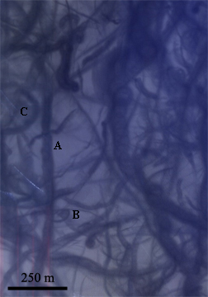

Figure 2: HiRISE PSP_004249_1255_IRB:
Dust devil tracks in Russell crater. The tracks are the result of removing the dust-mantled bright surface, revealing the darker substrate. Track types: linear, curved, and irregular morphologies. The Martian dust devil tracks generally vary from 10 m to greater than 200 m in width, and can range up to a few kilometers in length (Edgett and Malin, 2000; Balme et al., 2003; Fisher et al., 2005).

Aeolian processes are the dominant geological surface processes currently operating on Mars. Dust devils act as a mechanism to lift material off the surface and may have a large influence in the atmospheric dust cycle and global weather patterns. Dust devils also play a key role in albedo boundaries and could be responsible for initiating saltation, reactivating dormant dunes, or playing a role in defrosting dunes. The deposition and removal of dust also affects surface robotic operations and could potentially affect future human explorations.
There are two goals to this project: 1) Determine the physical morphologies of dust devil tracks in Gusev and Russell craters; and 2) Understand Mars' atmospheric interactions with the surface geology by replicating dust devil activity via modeling. The modeling is matching the observed rate of dust devil track erasure, the rate of airfall sedimentation constrained by atmospheric opacity values, and the amount of dust displaced by the dust devils themselves. Understanding temporal and morphological differences between the two study locations will shed light on seasonal variations as well as influences such as topography, sediment supply, latitudinal variations in the atmospheric dust cycle and local winds.

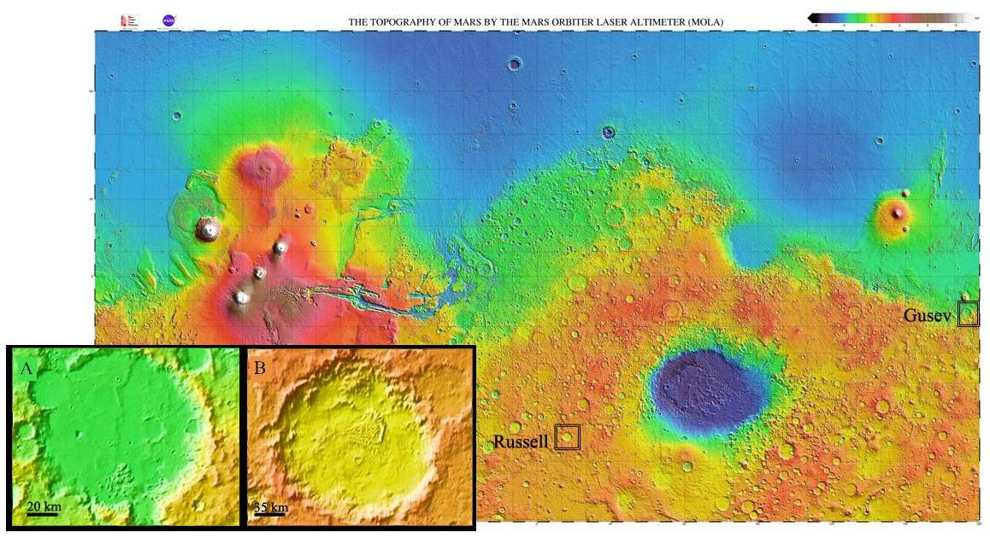

Figure 3: Mars Orbiter Laser Altimeter (MOLA) data from the Mars Global Surveyor (MGS) spacecraft depicting a global topographic map. A) Gusev crater (14.6ºS, 175.4ºE) & B) Russell crater (53.3ºS, 12.9ºE).

Geologic setting

The site areas of focus are Gusev crater at 14.6º S, 175.4 º E and Russell crater at 53.3º S, 12.9º E (figure 3). The locations were chosen to compare a “tropical”/equatorial crater (Gusev) to a southern mid-latitude hemisphere crater (Russell).
Gusev crater is an ideal location to study because it is the landing site of the MER Spirit and has a considerable amount of image coverage. Both the rover and HiRISE have taken many images of this 170-km-diameter crater in hopes of capturing a dust devil in motion as the dust devil leaves behind its track. The main region of interest in Gusev crater is the region around Columbia Hills (follows Spirit’s trek).
Russell crater is located in the southern mid-latitude region and is influenced by seasonal periods of deposition and sublimation of CO₂ frost. Russell crater is 140 km in diameter and has had several images taken for seasonal monitoring. The crater contains several intriguing aeolian features. A dune field on the crater floor is 30 km long and contains coarser-grained materials, as inferred from high night-time temperatures in THEMIS IR images suggesting high thermal inertia (Christensen et al., 2003). The Russell megadune is part of a very complex dune field that comprises two major tiers: an upper layer of transverse dunes, with a lateral dune rim that has gully channels on the southwest slope and a lower layer also comprised of linear or reverse dunes seen in the 3D model (figure 4). The transverse dunes were identified by the presence of the avalanche falls and slope streaks that appear during the winter season on the northwestern slip face. The lower linear dunes have a sinuous morphology and have no determinable slip face. The transverse dunes are controlled by a southeasterly wind with some influence by a northwesterly wind which could create a semi-linear morphology. The outer edge of the central dune field (of the study area) has star and barchanoid-barchan dunes controlled by a multidirectional wind regime.
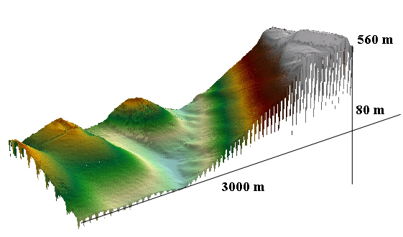

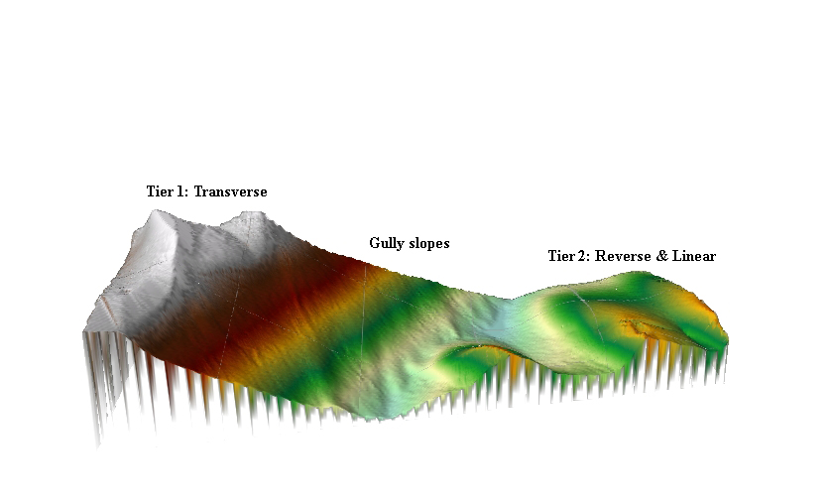
Figure 4: Two views of a 3D image created from the Russell dunes DEM in ArcScene with a 1.5 vertical exaggeration. The tier 1 dunes have a height of ~560 m with a slope angle of 17.13º between transverse dunes and slopes, versus tier 2 dunes at angle of 10.6º, a height of ~200 m of tier 2 linear/reverse dunes.

Based on digital elevation modeling (DEM) the upper tier dune height is about 560 m and the lower tier of dunes measure about 200 m. Reiss & Jaumann (2002) found the gully slopes to be 8º based on MOLA-track ap13426 whereas HiRISE data found the slope to be about 10.5º. The measurement from the top tier from crest to trough is ~398m and has a slope angle of 17.13º.

Background
Spirit has crossed over many dust devil tracks and has observed 533 active dust devils in motion during its journey in Gusev crater (Greeley et al., 2006). Spirit monitored the first dust devil season over period L_{S} 173.2º to 339.5 º from March 2005 to December 2005 with its peak of the season at L_{S} ~250º (Greeley et al., 2006). This is consistent with the results of many other studies which show that the peak occurrence of dust devils is during hemispherical spring and summer (Malin and Edgett, 2001; Balme et al., 2003b; Fisher et al., 2005; Balme and Greeley, 2006). Figure 5 depicts an active dust devil captured near a small crater near the Columbia Hills, as well as many dust devil tracks surrounding the Columbia Hills.

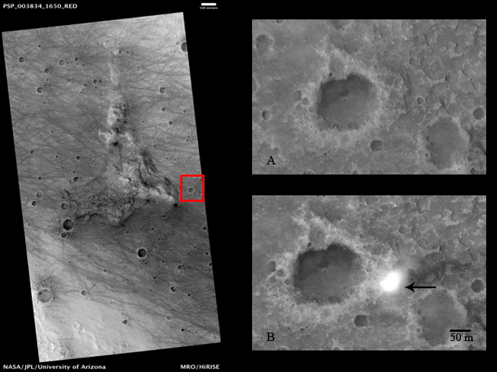
Figure 5: HiRISE Image PSP_003834_1650 with linear dust devil tracks surrounding Columbia Hills; boxed is the area of interest. Image A displays the area 5 days prior to image B. Image B PSP_003900_1650 with an active dust devil about 50 m in diameter.

Spirit’s Panoramic Camera (Pancam) recorded a range of clastic materials with fine ferric-oxide dust coatings, as well as imaging coarse sand, granules, and gravel (Bell et al., 2004). Most terrestrial dust devils form a column with a "skirt" that contains larger particles that are too large to be carried in suspension (seen previously in figure 1). Many of the dust devils in Gusev crater lack this vortex skirt, which suggests that granules and sand grains are unable to be picked up by Martian dust devils (Greeley et al., 2006). Hence dust devils in Gusev crater apparently only entrain the lighter dust particles; heavier material may be buried deep under the dust or sand-sized particles are lacking in the area or the wind speeds are not strong enough to pick up material.
Spirit also found that ripples around the landing site had a layer of well-sorted coarse particles over finer grains on the crest and poorly sorted grains in the trough (Arvidson et al., 2004). Arvidson et al., suggest that the wind, or dust devils, remove the finer material leaving the coarse grains on the ripples.
Spirit observations reveal that dust devils preferentially occur in a low albedo zone on the floor of Gusev crater as the surface heats more easily with the dark surface (Greeley et al., 2006). Balme et al. (2003b) used albedo as a proxy for dust abundance, which likely controls the formation of dust devils. Nilosyrtis (54.28º N, 67.31º E), where the surface albedo has changed drastically, displays strong evidence that dense patches of dust devils are a significant influence in albedo variations (Geissler, 2005).
Some regions display higher dust devil activity rates than other regions. Fisher et al. (2005) surveyed Martian dust devils using Mars Orbiter Camera (MOC) images from the Mars Global Surveyor (MGS) and examined over 175,000 wide (230 m/pixel) and narrow-angle (<10m/pixel) MOC images in their survey of dust devils. Their focus was a geographical sampling of nine regions and a focused study on an active dust devil area in Amazonis Planitia. They found the highest dust devil activity was found in Amazonis (25-45 º N, 195-215 º E) and Casius (45-65 º N, 75-105 º E) during northern spring and summer (L_{S}= 315 º -45 º; L_{S}= 45 º -135 º). Amazonis is expected to be a region of high dust lifting based on modeling by Newman et al. (2002), and thus observations support the models in this area.
Russell crater was targeted for dust devil monitoring in this study as there has been very little research done in this region. The recent interest in Russell crater has been focused on the possible role of liquid in the formation of gullies observed on the dune slopes in a MOC image (Reiss and Jaumann, 2002). Dust devil tracks extend from the troughs to crests of these dunes. HiRISE images originally targeted on the gullies extending from the dune field, also depict mass concentrations of dust devils tracks on these dunes.

Chapter 2
Thermodynamical Theory
Dust devils predominately lift dust since the central low pressure is surrounded by tangential winds and strong vertical velocities. Dust devil formation is influenced by the flux of solar energy and the ambient surface pressure and temperature (Newman et al., 2002). The purpose of this chapter is to understand the theoretical framework to the mechanisms of producing a dust devil.
The physics of dust devil formation and movement is derived and summarized from a set of equations involving convective circulations generated by surface heterogeneities. The thermodynamics of heat engines (summarized below) provides a mechanism for producing dust devils and can be applied to a mesoscale circulation (Souza et al., 2000; Renno et al., 1998).

Formation of dust devil
Martian dust devils are cyclostrophic convective vortices induced by solar heating of the Martian surface. Air flows radially inward towards the low-pressure core and upwards as warm, buoyant near-surface air is displaced by the surrounding cool, dense air (Sinclair, 1966; Renno et al., 1998). If the surface is covered in dust, the atmospheric motions cause the dust particles to become airborne, making the vortex visible while exposing the darker substrate beneath the dust mantled surface. This process leaves conspicuous dark tracks that provide clues to the behavior of Martian dust devils.
Since dust devils depend on local wind shear to move, ‘failed’ vortices can form but will remain stationary. Similarly, there can be atmospheric instability but no formation of a visible dust devil if the shear intensity is not strong enough to pick up material.
A convecting air parcel in a steady state and non-rotating frame of reference is expressed in terms of a change in velocity and elevation as the volume of air changes pressure over vertical distance. This follows the conservation of energy as pressure changes (contracts or expands).

$d(\frac{1}{2}{\left|v\right|}^{2}+\text{gz})+α\text{dp}−fdl=0$ (1)

where v is the velocity vector, g the acceleration due to gravity, α the specific volume, p the pressure, f the frictional force per unit mass, and dl is an incremental distance along the air parcel’s path.

The integration of equation 1, in a closed circulation, with the mass (integral of m) over the entire volume occupied by the convective system is normalized by its mass which results in a steady state. The work done by a convecting air parcel therefore equals the frictional loss of energy.
Conservation of Mass states that ∂ρ/∂t + ∇⋅(ρv)=0. In a steady state, the density (ρ) does not change with time, which yields ∇⋅(ρv)=0 where the density (ρ) is constant and v is the velocity vector. This results in ∇⋅v=0 where ∇=$\frac{∂u}{∂x}+\frac{∂v}{∂y}+\frac{∂w}{∂z}$.
This equation states that the partial derivatives of the velocity vector components added together are equal to zero. The ½ |v|² (from Equation 1) is negligible as the partial derivative of the velocity term is equal to zero as given by ∇⋅v=0. The gz term is also negligible simply due to the derivative of a constant that is zero. Hence, equation 1 becomes:

$\int_{m}{α\text{dp}=\int_{m}{\text{f }⋅dl}}$ (2)

Approximating the convective vortices as reversible heat engines, the first law of thermodynamics within moist air can be written as

$\text{Tds}=d(cpT+Lvr)−α\text{dp}$ (3)

Where T represents the absolute air temperature, s the specific entropy, c_{p} the dry air specific heat at constant pressure, L_{v} the specific latent heat of vaporization, and r the water vapor mixing ratio.

Integrating equation (3) over the entire mass of the dust devil convective volume in steady state conditions gives equation (4). Equation (4) indicates that temperature is related to the volume and pressure, meaning the work done in the circulation is equal to the net heat input. Equation 4 is simply due to the ideal gas law is substituted in (remembering $(cpT+Lvr)$= $α\text{dp}$ for simplicity and re-added later).

$\int_{m}{\text{Tds}=−\int_{m}{α\text{dp}=\int_{m}{\text{pd}α}}}$ (4)

The net heat produced by a dust devil must also balance the frictional loss of energy in equation (5). In a steady state, the net work done by a heat engine balances the friction. This implies that the more intense the vortex, the more work it does, and thus results in more friction. Alternatively, the more friction produced by a dust devil, the more work is required to produce a steady state.

$\int_{m}{\text{Tds}=−\int_{m}{f⋅dl}}$ (5)

To find the frictional loss along a pathway (from point a to b across dune topography) assuming a closed system where air mass is recycled and where there is no loss of energy from point a to b or along the reverse path of b to a. Neglecting changes in kinetic and potential energy and assuming that v and g are constant, equation 1 then gives:

$\int_{a}^{b}{\text{αdp}≈\int_{a}^{b}{f⋅\text{dl}−\int_{a}^{b}{\text{gdz}}}}$ (6)

Renno et al. (1998) defined the fraction of mechanical energy that is dissipated by friction at the surface from point a to b over a closed system as

$γ≡\frac{\int_{a}^{b}{f⋅dl}}{\int_{m}{f⋅dl}}$ (7)

The thermodynamic efficiency (η) of the convective circulation is defined as the net work done over the heat input. Recalling that $\int_{a}^{b}{\text{Tds}}$ is the heat input of the dust devil and neglecting any contribution of frictional heating to this heat input, I can define η as

$η≡\frac{\int_{m}{\text{Tds}}}{\int_{a}^{b}{\text{Tds}}}$ (8)
Combining equations 5, 6, 7, and 8 gives equation (9)

$\int_{a}^{b}{α\text{dp }}≈−\text{γη}\int_{a}^{b}{\text{Tds}−\int_{a}^{b}{\text{gdz}}}$ (9)
Equation (3) becomes:
$\int_{a}^{b}{\text{Tds}}=\int_{a}^{b}{}d(c_{p}T+L_{v}r)−\int_{a}^{b}{α\text{dp}}$ (10)

Combining equations (9) and (10) gives

$(1−\text{γη})\int_{a}^{b}{α\text{dp}}=−\text{γη}\int_{a}^{b}{d}(c_{p}T+L_{v}r)−\int_{a}^{b}{\text{gdz}}$ (11)

Using the ideal gas law $\text{PV}=\text{NRT}−−α=\frac{\text{RT}}{P}$ (specific volume, α, is equal to V/N) and by neglecting changes in specific heat and specific latent heat of vaporization (a reasonable assumption in dry convective systems) gives equation 12.

$pb≈pa\text{exp}\left\{\frac{\text{γη}}{(\text{γη}−1)R}\left[\frac{cpΔT}{\bar{T}s}+\frac{LvΔr}{\bar{T}s}\right]+\frac{1}{(\text{γη}−1)R}\left[\frac{gΔz}{\bar{T}s}\right]\right\}$ (12)
[Part] A B C

Where ΔT=T_{b}-T_{a}; Δr=r_{b}-r_{b} Δz=z_{b}-z_{a}; $\overline{T_{s}}$ is the mean surface air temperature between points a and b.
Part A in equation (12) represents the absorption of sensible heat between point a and b. Sensible heat is the heat exchange leading to changes in temperature without accompanying phase changes. This is in contrast to latent heat which is heat exchange leading to phase changes without accompanying changes in temperature. Because there is no latent heat in a dust devil, assume sensible heat, thus part B can be ignored. Part C represents the hydrostatic pressure drop from the difference in elevation and upslope nonadiabatic expansion.

$ΔT=ΔT\text{ad}+ΔT\text{na}=−\frac{g}{cp}Δz+ΔT\text{na}$ (13)
The adiabatic (ad) and nonadiabatic parts (na) are represented by the dry adiabatic lapse rate and the heat obtained by the dust devil in equation (13).
Substituting equation (13) into (12) gives a relationship for the pressure difference between point a and b.

$Δp≈pa\left\{1−\text{exp}\left[\frac{\text{γη}}{(\text{γη}−1)R}\left(\frac{cpΔT\text{na}}{\overline{Ts}}+\frac{LvΔr}{\overline{Ts}}\right)−\frac{Δz}{Hs}\right]\right\}$ (14)
This relationship of the pressure is represented by: $Δp≡pa−pb;ΔT\text{na}=Tb−Ta+\left(\frac{g}{cp}\right)Δz;Hs=\frac{R\overline{Ts}}{g}$(scale height)
Equation (14) shows that the net work performed by a dust devil is proportional to the radial pressure change, which in turn predicts intensity of the dust devil. Topography enhances convective circulations for near-surface nonadiabatic heating of air parcels moving upslope and thus enhances dust devil activity.
The surface heats up from solar radiation (higher heat capacity), whereas the near surface retains heat and remains constant (assuming homogenous surface). As an air parcel increases in elevation, the calculated air temperature changes ~4.9 K per kilometer (Martian dry adiabatic lapse rate). The larger the difference between the surface and air temperature, the greater the heat transfer (strongest surface heat flux). This creates the potential for intensification of the dust devil (horizontal temperature gradient). The intensity depends on the depth of the convective plume and the existence of local wind shear (Renno et al., 1998). Dust devils can exceed 6 km in height in the thermal updraft region (the area above the dust devil that extends to the top of the convective boundary layer) <10 km above zero elevation (Smith et al., 1999).
The intensity of a dust devil must follow a thermodynamic efficiency representing a heat source and sink. Using equation (8)

$η≡\frac{\int_{a}^{b}{\text{Tds}−\int_{\text{out}}{\text{Tds}}}}{\int_{a}^{b}{\text{Tds}}}=\frac{Th−Tc}{Th}$ (15)
T_{h} is the temperature of a hot reservoir (mean surface air temperature) and T_{c} is the temperature of the heat sink (i.e. the convective boundary layer). Recall:
$$\int_{m}{\text{Tds}=}\int_{a}^{b}{\text{Tds}−\int_{\text{out}}{\text{Tds}}}$$
For a dry reversible heat engine, the entropy-weighted average temperatures of the heat source is the average of the surface air ($T=\overline{T_{s}}$) and the temperature of the convective boundary layer. According to the Second Law of Thermodynamics, it is impossible to convert all mechanical energy into useful work because some of the energy produced from the hot reservoir (the heat source) must be put into the cold reservoir (heat sink). The heat source, the insolated surface, is the source of energy for the heat engine. The energy to form a dust devil is taken from the heated ground and then is released into the top of the convective boundary layer (heat sink).
The convective boundary layer is constant with height resulting in the temperature of the boundary layer air being equal to its average temperature. According to Renno et al. (1998) this indicates that the dust devil is a function of the thickness of the convective layer and cooling rates. Incorporating the dry adiabatic lapse rate as a function of the depth of the convective boundary layer ($Γ_{d}Z$ ) gives the thermodynamic efficiency as:
$$T_{c}≈{\text{ T}}_{h}\text{ - }Γ_{d}Z$$
$η≈\frac{\text{gZ}}{cpTh}$ (16)
Equation (16) is derived from Golitsyn (1979) and signifies that dust devils transfer heat by convection, rather than conduction, with Z representing the depth of the convective boundary layer.
As the core pressure increases, this decreases core radius and increases intensity. In a few HiRISE observations the dust devil expands in radius as velocity decreases (moves down into dune trough). The velocity increases up-ridge of dunes and intensifies (radius decreases). The intensity of a vortex increases in the fraction of total dissipation of mechanical energy near the surface.

$$\left|v\right|≈{\left[\frac{η}{μ}(cpΔT\text{na}+LvΔr\right]}^{1/2}$$
The intensity (v) of the change in elevation (i.e. the dune field) based on the motion of the dust devil from higher entropy surfaces (warmer) to lower (colder) circulation. Constant μ is a magnitude of the dimensionless coefficient of dissipation of mechanical energy.
Basic movement
The basic forward movement of dust devils is due to the ambient wind speed. Tangential, radial, and vertical velocities depend on the internal mechanics of the dust devil itself. The tangential velocity is based on the pressure difference between the inside and outside of a dust devil. Horizontal shear determines the direction that the dust devil rotates.
Dust devils follow a cyclostrophic (Equation 17) where the centrifugal forces are balanced by the pressure gradient forces (Sinclair, 1966). One assumption is that the width of the track equals the width of the vortex core radius. This assumption is inaccurate, as discussed in interpretation.
$\frac{V_{a^{2}}}{R}=−\frac{Δp}{ρΔn}→V_{a}=\sqrt{\frac{R}{ρ}\frac{Δp}{R}}$ $\frac{V_{a^{2}}}{a}≈α\frac{Δp}{a}$ (17)
Remembering that density is equal to: $ρ=\frac{p}{R∗T}$
And that $α=\frac{1}{ρ}$
Where V_{a}= tangential wind speed; a/R= vortex radius; α= specific volume of air, Δp is the radial pressure drop across vortex (Renno et al., 2000). This follows ideal gas law and the radius can be neglected in its relation to the intensity.

$Va≈\sqrt{\frac{\text{RT}sΔp}{ps}\frac{M}{n}}$ (18)

R is the atmospheric specific gas constant, T_{s} and p_{s} are ambient surface air temperature and pressure, respectively. The molecular mass (M) of the Martian atmosphere must be accounted for. Equation 18 is used to find the tangential wind speed based on HiRISE observational data.
Chapter 3
Methods
Images utilized in this study were obtained from the HiRISE camera. HiRISE images have a resolution of 1 microradian (25-30 cm/pixel) in three color bands, blue-green (400-600 nm), red (550-850 nm), and the near infrared (800-1,000 nm). Fourteen images of Gusev crater and 15 images of Russell crater were obtained from the HiRISE Primary Science Phase (PSP). Images and work databases are in the Digital Appendix.
HiRISE images were used in this study because the resolution is much higher than previous images taken of Mars. In addition, Gusev and Russell craters have repeated coverage intended for seasonal monitoring. Mars Orbiter Camera (MOC) images were previously used to monitor Gusev crater (15 images) and Russell crater (10 images) in Digital Appendix. The combination of MOC and HiRISE imagery of the sites provides a longer time frame to accurately determine the dust devil seasons. This also allows a comparison of the surface detail of the MOC and HiRISE images that can be used to determine whether HiRISE images offer any significant advantages.

Image Processing
To interpret the dust devil activity in the images, the morphological and quantitative data were derived through image processing. The images were first analyzed using Integrated Software for Imagers and Spectrometers (ISIS2/ISIS3) by comparing areas of images that overlap (figures 6/7).
First ‘jpeg’ formatted images were transferred into cube format for ISIS2 to read in order to get a generalized idea of the changes. The images were tied together using tie points of specific features, such as the dunes or rills in Russell crater, in each image to create a sequence based on the L_{S} season. The tie points were then saved to a control point file using ISIS2 “Qview” and program “random” using 1 degree to create a tfile.dat of the data from the registered control file. The images were then run in “warp2” which transforms the shape of the cube with a weighted second order fit. Lastly, “geom” transforms the image plane of the cube file by changing the spatial relationship between the points within each image plane. After processing the jpeg images, the blink tool was used which switches between aligned images, making any changes in dust devils tracks apparent.
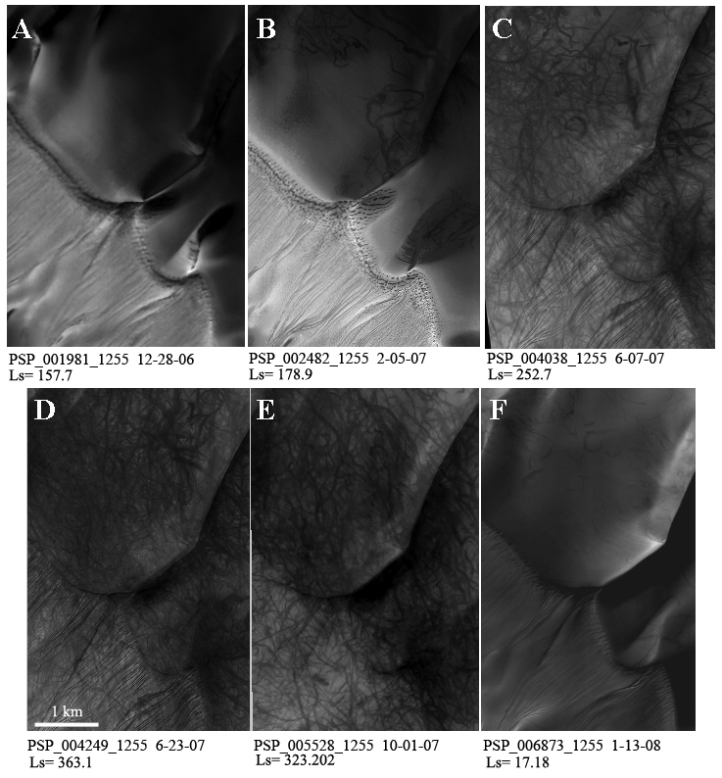

Figure 6: Analysis of dust devil changes in Russell crater. A-B) Dunes are covered in CO₂ frost early in the spring season; sinuous track morphology is evident as the surface begins to defrost. C-D) Increase of dust devil activity with decrease of surface albedo. E-F) Tracks are covered as dust is deposited and the dune ridges begin to frost over.

Figure 7: Changes in Gusev crater: A) Slow increase in dust devil activity; B) Large increase of activity; C) 2007 dust storm erases tracks; D) Increase of dust devil activity after dust storm; E-F) No erasure or dust deposition to end of season.

Original map-projected ‘jpg2000’ images were then processed in ISIS3 and converted into cube format for a higher resolution examination. ISIS3 programs were used in comparison to ISIS2 due to the size of the HiRISE images and processing capabilities. Due to the size of the original images (26 Gb), the images were reduced in size and resolution. Images were map projected accurately using the program “map2map” and “mapmos.” “Map2map” alters the projection of the cubes that are already in map projection. In this case, the HiRISE image pixels were used utilizing the bilinear interpolator. “Mapmos” creates a mosaic of the projected cubes based on the latitude and longitude range of the HiRISE images. Figure 8 displays processed images for a quick seasonal qualitative analysis in ISIS3 and enlarged “Qview”.
MOC images were also spatially matched using “mocproc.” Mocproc runs MOC images through the applications necessary to create a map projected product in three stages of processing: ingestion, calibration, and mapping. Mocproc converted “.imq/.img” formats into “cube” formats. In this case, the mapping parameter is disabled but kernel data is added to the MOC images and produces a nonmapped projected image. The nonmapped projected image is then matched to a HiRISE map projection to register points in ISIS3 “Qtie.” About 15-20 points were registered in the best fit area of the MOC and HiRISE overlap, with a pixel error of 1 which is combined with the program, “geom” and warped the MOC images to match the HiRISE base projection. Geom is used to perform the geometric transformation of image planes in an ISIS cube file.

Figure 8: Image processing and modification in ISIS3 Qview; and viewing JP2000 full scale of gullies and albedo boundaries of the dust devil tracks in IAS Viewer.

Using ESRI’s ArcMap & ArcScene
To transfer the images into ENVI ArcMap, GDAL in ISIS3 was used to translate ‘jpg2000’ images in ISIS3; program dos2unix fixes a projection file based on the label file and program ‘pds2world.pl’ creates the projection file and creates a world file required for ArcMap; a world file is a plain text computer data file to georeference a raters mapped image. Using the lower resolution ‘jpg2000’ image created in ISIS3, the image is loaded into ArcMap with the projection and projected over a THEMIS world file projection from the Mars Global Digital Dune Database (Hayward et al., 2007).
One objective of the project is to understand the direction of travel of the dust devils. The forward direction of a dust devil can be determined based on the laboratory experiments by Greeley et al. (2004). This procedure simulates tracks with overlapping scallops and looping patterns, as seen in figure 9.

Figure 9: Image and diagram of an experiment run with the Arizona State University Vortex Generator, an apparatus used to simulate dust devils. Overlapping scallops determines direction dust devil is moving. (Malin and Edgett, 2001; Greeley et al., 2004)
Once images were projected into ArcMap, the ‘editor’ option was used to map the tracks. Directions were determined and digitized over the tracks and placed in a separate shapefile. Increasing the color contrast of the image and comparing the image with higher resolution image helped determine the majority of directions. The tracks within the shapefile were divided into three categories: direction-determined tracks, tracks found in the previous image, and new tracks without determined direction (example seen in results, figure 11).
Once the tracks were mapped in ArcMap, they were quantified based on their density, length, width, and sinuosity. These characteristics were measured for tracks in Russell and Gusev crater. To determine the track density, the total track area was compared to total area of tracks ratio in each image, and a ‘buffer’ shapefile was applied to the lines that represented the tracks. The lines did not accurately depict the width of tracks. To determine the ‘buffer’ and the widths of the tracks themselves, lines were drawn across the width of the tracks. The average width of each image was then applied to the ‘buffer’ width. Track densities were derived by comparing the total area of tracks in each image to the total image area. These densities were plotted in graphs and compared to one another to determine the peak of the track season (results, figure 13).
Lastly, the length and sinuosity were calculated using Hawth’s Tool’s (ArcGIS analysis add-on tool) and plotted in graphs (results, figures 14-16). The sinuosity is a line feature in Hawth’s Tool that is calculated by taking the number of line segments (n) that make of the line and the distance of the line (d) and the line of the cumulative length of the line of all line segments (L) as D= log(n) + log (d/L).
Global Climate Model
Winds less than 30 m/s were obtained from the NASA Ames General Circulation Model (GCM) and were added to ArcMap using model output collected from Hayward et al. (2007). Small magnitudes winds <10 m/s, were also added to this collection of wind magnitudes since it was not included in the original GCM (T. Titus, personal communication, 2008). The GCM model output was separated into ideal solar heating time (1300-1500 local mean time) and seasons when dust devil activity occurs. Four model predictions of wind orientations and strengths in Gusev and Russell craters were created (results, figure 12). Output from the Ames Mars GCM (Haberle et al., 1999) included detailed attributes of shear stress, wind velocity and direction to understand the modeled atmospheric behavior. The height of the reported wind velocity varies with pressure and is typically between 3 and 8 meters above the surface (Hayward et al., 2007).

Russell Crater Dunes Digital Elevation Model
A Digital Elevation Model (DEM) was made of a portion of Russell crater using stereo HiRISE images PSP_007018_1255 and PSP_007229_1255 (Mattson, S., 2008). The height and distance of the dunes and slope angles were measured from the DEM using the ISIS3 ‘Qview’ program. The upper tier dune height is about 560m and the lower tier of dunes measure about 200m. Reiss & Jaumann (2002) found the gully slopes to be 8º based on MOLA track ap13426 whereas HiRISE data found the slope to be about 10.5º. The measurement of the top tier from crest to trough is ~398 m and has a slope angle of 17.13º.
After formatting the image from a cube format into a ‘tiff’, the image was transferred into ESRI’s ArcScene and ArcMap. Inputting the DEM into ArcMap allowed comparison to the HiRISE images. The color values of the DEM were changed into a standard low-high color ramp (Figure 10). The DEM was then imported into ArcScene as a raster file to create and render a 3-D model. ArcScene is a 3D visualization application that allows viewing GIS data in three dimensions by overlaying many layers and shapefiles. Features get a reading height from feature geometry, feature attributes and layer properties to define the 3D surface. These 3D Analyst reprocessing tools allow the 2D image to look like a 3D surface. Using obtained heights from the layer, a rendered surface with a 1.5 vertical exaggeration was created by adding in the hillshade effect and slope (z-factor of 10) in 3-D Analyst tool (refer back to figure 4).

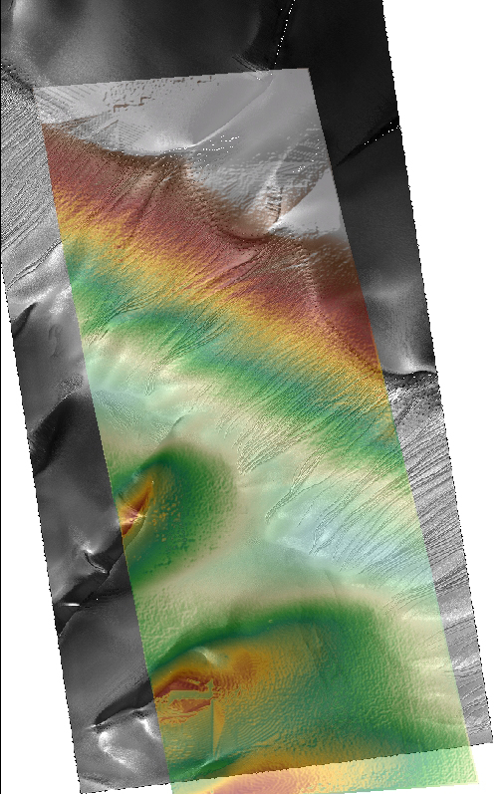

Figure 10: Colored elevation DEM of Russell crater overprinted on PSP_001981_1255 to create 3D image of the Russell dunes. Color gradient relative to elevation height: Red (highest) to light blue (lowest). DEM calibrated by Mattson, S. (2008)

Chapter 4
Results
Detailed Image Analysis
In this section, I have provided a detailed description of dust devil and frost activity in each HiRISE image. Refer to Digital Appendices to follow the changes of the dust devil season and the following tables 3 and 4 for quantitative analysis. Specific HiRISE and MOC observations and notes can be found in table appendix (tables 3-6).
Table 1A: Gusev Crater Specifics

PSP_001513_1655  Ls= 139° | Thin veneer of dust on surface, darker albedo with some minor tracks some that go to the SE, some to NE (late winter/early fall still has winter winds). | Width 42.33 m  Length wide range; 700-6000 average 2011 m  Sinuosity 1.19  Areal coverage 2.37%
PSP_001777_1650  Ls= 149° | Surface is the same as previous image with the influence of winter wind (wind tracks) that have tracks with no apparent fading. 23 new tracks longer tracks to SW and extend over Columbia Hills. | Width 44.39 m  Length wide range; 2033 m  Sinuosity 1.06Areal coverage 3.09%
PSP_002133_1650  Ls=163° | Thin image strip; Hard to tell if there are new tracks. | Width 30.86 m  Length wide range; 1260 m  Sinuosity 1.12  Areal coverage 2.36%
PSP_003689_1650  Ls=235° | Increase of new tracks (126 new tracks; erasure of almost all previous tracks) with directions from NW/SW dominated. Longer tracks- more or less the peak of season in late spring. Tracks are creating/sustaining a darker albedo feature south of Columbia hills. | Width 65.1m  Length wide range; 2320 m  Sinuosity 1.07  Areal coverage 34.45%
PSP_003834_1650 Ls=242° | 49 new tracks directional to ESE; areal coverage could be higher but dark albedo south of Columbia Hills prevents distinguishable tracks (lack of dust). | Width 63.1 m  Length wide range; 2627 Sinuosity 1.06  Areal coverage 32.52%
PSP_003900_1650 Ls=245° | 23 new tracks Areal coverage could be higher but dark albedo feature south of Columbia Hills prevents distinguishable tracks (lack of dust). Tracks appear to be wider but coverage is decreasing. | Width 88.4 m  Length wide range; 2415m  Sinuosity 1.05  Areal coverage 29.31%
PSP_004256_1650 Ls=263° | 33 new tracks loss of dust layer and overprinting, and darker albedo surface, areal coverage could be higher but still lack dust. | Width 88.3 m  Length wide range; 2257 m Sinuosity 1.04  Areal coverage 21.3%
PSP_005034_1650 Ls=300° | Dust storm hits; the area NE of Columbia Hills has wind streaks and lacks dust layer whereas the area NE/E/SE appears to have a net dust deposition (higher albedo) with tracks only going to SE. | Width 61.7 m  Length wide range; 4656 m  Sinuosity 1.02  Areal coverage 6.77%
PSP_005245_1650 Ls=310° | Dust devils begin to remove dust (53 new tracks) directions to SE. | Width 49.59 m  Length wide range; 4116 m  Sinuosity 1.14  Areal coverage 16.01%
PSP_005456_1650  Ls=320° | Newer tracks lead more E/NE direction (108 new tracks) but there is still a lot of dust mantling. Mostly overprinting from previous tracks. | Width 51.84 m  Length wide range; 2726 m  Sinuosity 1.13  Areal coverage 18.13%
PSP_006524_1650  Ls=4° | 97 new tracks; however, the image does not align with previous ones so there is an assumption that there are only a few new tracks as it appears that older images can be extended into this image. | Width 40.1m  Length wide range; 2598 m  Sinuosity 1.16  Areal coverage 18.62%
PSP_006735_1650 Ls=12° | 76 new tracks directions E-SE Columbia hills darkening and dust devils overprinting. | Width 61.32 m  Length wide range; 3006m  Sinuosity 1.16  Areal coverage 16.7%
PSP_008963_1650 Ls=90° | 21 new tracks that are very short, Columbia Hills region much darker but still has a dust mantle area with no dust devil tracks. | Width 52.32 m  Length wide range; 2419 m Sinuosity 1.18  Areal coverage 8%
PSP_009174_1650  Ls=97° | No new tracks in this image and older tracks are slightly faded. | Width 52.1 m  Length wide range; 2419 m  Sinuosity 1.19  Areal coverage 7.67%

Table 1B: Russell Crater Specifics
PSP_001440_1255 11/16/2006 Ls= 136.335° (late winter) | There are no dust devil tracks in this image.
PSP_001981_1255 12/28/2006 Ls= 157.704° (very early spring) | The dunes are still covered in frost with minor CO₂ sublimation. Two tiny looping tracks are seen on the leeway of tier 1 dunes.
PSP_002337_1255 1/25/2007 Ls= 172.6o (early spring) | The dunes are defrosting more than previous image as the surface begins to warm, CO₂ is sublimating. Start of the dust devil season begins with curvy morphology that forms on the slip faces (left side) on tier 1 dunes. One track follows the edge permafrost and is affected by the frost. | Width 10-60 m; average 21 m Length 200-300 m  Sinuosity 1.1 Areal coverage 2.35%
PSP_002482_1255 2/5/2007 Ls = 178.9 (spring) | The dune still has defrosting dune crests (tier 1) to gully alcoves with the trough and sun facing slip face fairly free of frost. The main morphology type is curvy, although there are some slightly linear tracks as the tracks increase in length. | Width 20-100 m; average 41 m  Length 400, 2000 m (bimodal) Sinuosity 1.1- 2; 1.1 Areal coverage 6.81%
PSP_002548_1255 2/10/2007 L_{s} = 181.8 (spring) | The dunes are still defrosting. Many tracks from previous image are present and are slightly faded. Very little new tracks. | Width 20-100 m; average 35.8 m Length 400, 2000 m (bimodal) Sinuosity 1.1-1.2 Areal coverage 8.54%
PSP_002904_1255 3/10/2007 L_{s} =197.894° (middle spring) | The dunes are completely defrosted except the dune lip where the gully alcoves slope down from tier 1 dunes. Previous tracks from PSP_0002482/2548 are gone and there are only a few new tracks. The surface appears to be dark that may be from the lack of loose dust. Bright streaks near the head of gullies show that there is an increase of wind. | Dust factor: 0.37 Width 30-70 m; average 42.29 m Length widespread;  average 2000 m Sinuosity 1.1 Areal coverage 4.43%
PSP_003326_1255 4/12/2007 L_{s} =217.794° (middle-late spring) | There is still slight defrosting action at gully alcoves. Dust devil activity increases dramatically on both dune tiers. Dominant dust devil morphology on tier 1 are long and linear. | Dust factor: 0.385  Peak width of season  Width 30-100 m; average 57.8 m Length, bimodal average 2000 m Sinuosity 1.1 Areal coverage 34.75%
PSP_004038_1255 6/7/2007 L_{s} =252.689° (late spring) | Large agglomerations of tracks on both sets of dunes: some tracks stretch from dune crests, down into the gulley slopes and into lower dunes. | Width 10-100 m; 50.93 m  Length wide range; average 2000m Sinuosity 1.1 Areal coverage 51.15%
PSP_004249_1255 6/23/2007 L_{s} =263.109° (early summer) | Dust devil tracks density high (begins the range peak affected by 2007 dust storm). There are very few older tracks from previous image. The tracks move perpendicular over gullies and seem to prefer to go uphill. | Width range 10-100; 50.51m  Length 200-4000 m ; 2000 m  Sinuosity 1.1  Areal coverage 48.68%
 | **Peak tau July 25** DUST STORM
PSP_005238_1255 9/8/2007 L_{s} =310.265° (late summer) | The surface is slightly brighter after the dust storm which erased all previous tracks, and dust devil track density decreased. The majority of tracks are on tier 1 dunes whereas the southern set (tier 2) of dunes has very short dust devil tracks. | Dust factor: ~0.57 Width range 20-80 m; 31.88 m Length 100-5000 m; bimodal peak 300, 2000 Sinuosity 1.1 Areal coverage 30.42%
PSP_005383_1255 9/19/2007 L_{s} =316.793° (late summer/early fall) | Technical peak of Russell tracks, addition of many new tracks. Preference of track location either on top of dune ridges, gully slopes from tier 1 dunes. | Width range 20-70; average 37.9 Length 200-4000; bimodal 300, 2000 m Sinuosity 1.2 Areal Coverage 51.99%
PSP_005528_1255 10/1/2007 L_{s} = 323.2º (early fall) | Overlapping tracks from previous image, some complete erasure of track with track that follows near an old track. Wider tracks. | Width range 20-80; 39.81 m Length 200-4000m; 2000 Sinuosity 1.1-1.2 Areal coverage 51.62%
PSP_006873_1255 1/13/2008 L_{s} = 17.18º (fall) | Erasure of majority of the tracks; some minor tracks from previous image. Presence of short new tracks on tier 1 and lee side of tier 2. Image doesn’t complete overlap, causes issues. | Width range 20-50; average 29.64 m Length 200-2000; 300, 400, 2000 m Sinuosity 1.1 Areal coverage 9.62
PSP_007018_1255 1/25/2008 L_{s}=22º (fall) | Possible new tracks unlikely, image overlaps on left edge with previous image. Previous image tracks gone. | Width range 20-60; 28.99 m Length 200-4000; 300, 2000 Areal coverage 5.16%
PSP_007229_1255 2/10/2008 L_{s}=30º (late fall) | Not complete image overlap with previous. Overlaps with PSP_006873_1255; segments of tracks present; majority of tracks are new. | Width range 20-50; 26.2 m  Length 200-4000; 400, 2000 m Areal coverage 7.95%

Russell crater post initial study:
PSP_007519_1255 3/4/2008 L_{s}=40.3º | Barely overlaps with previous image. Presence of new tracks (larger width) and small segmented pieces from erased previous tracks. Density estimate ~5%.
PSP_009879_1255 9/4/2008 L_{s}= 122º | Dunes are covered in dust, white/dark slope streaks and some minor frost is present. No tracks!
PSP_010090_1255 9/20/2008 L_{s}=130º | No changes from previous image. Dunes are still covered in frost and sublimation is occurring.

Results Summary
This section summarizes the dust devil seasons in Gusev and Russell craters throughout an entire season created from analysis of individual HiRISE and MOC images.
The mapped tracks in both craters are compared to model predictions of wind orientation and strengths based on global circulation simulations (figures 11 and 12). Tracks in Russell crater are aligned with the northwesterly oriented prevailing wind as predicted by the GCM. The winds moving towards the northwest (southeasterly wind) matches winds seen during the season in which tracks are seen moving up the larger gully slope to top tier of dunes. The tracks in Gusev crater also match the predicted GCM peak daytime winds also from northwesterly direction; however, there are also tracks that lead to the northeast, consistent with secondary crater winds or winter winds (as shown by L_{S} comparison).

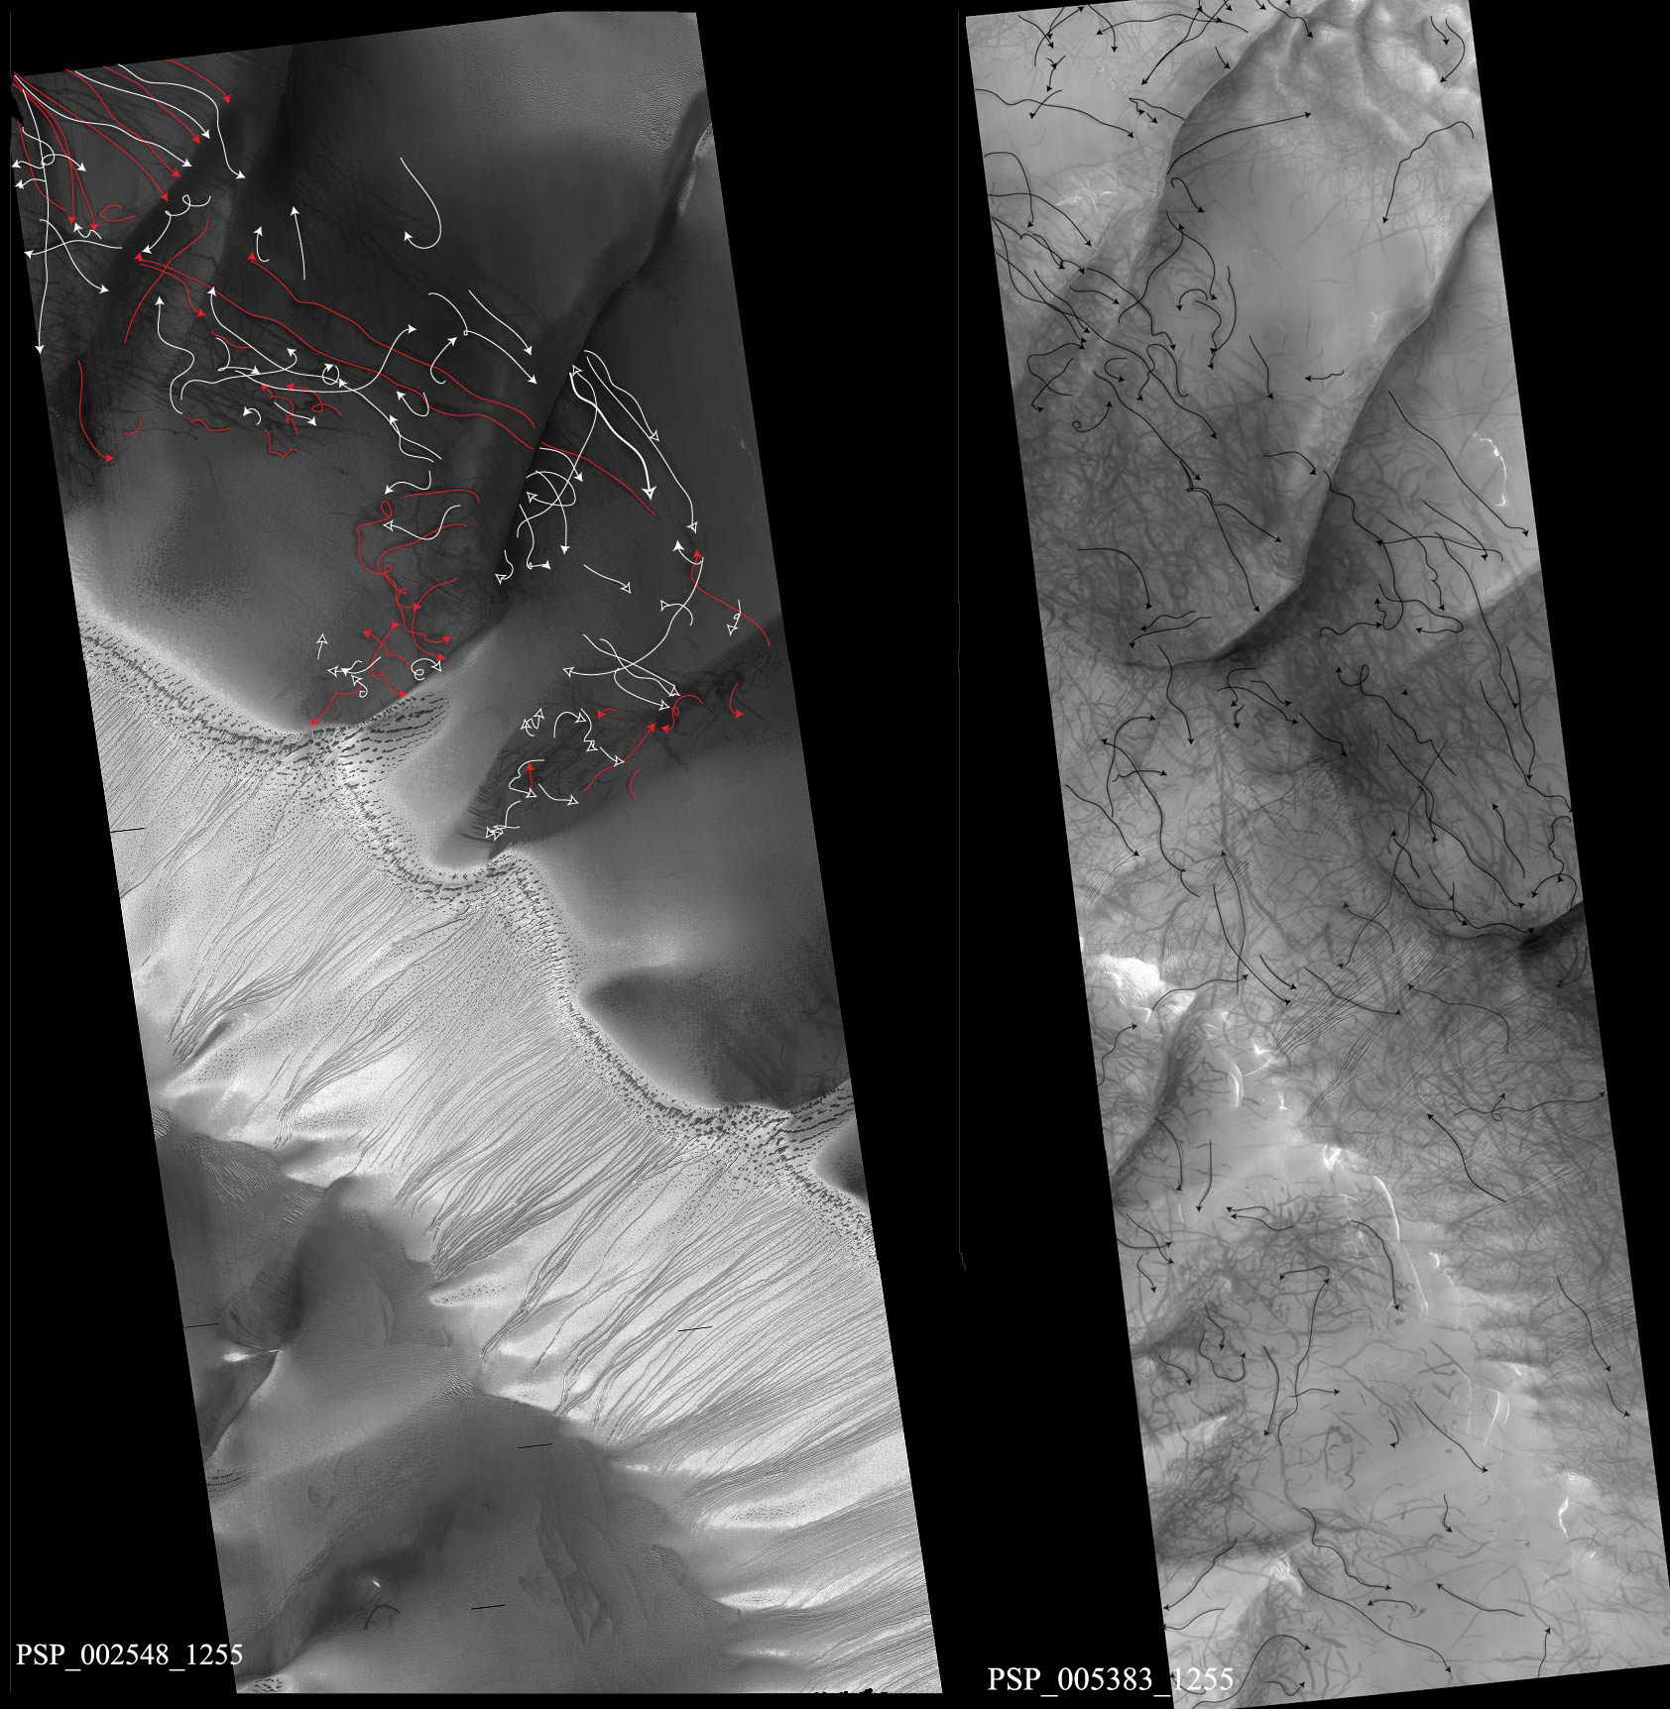
Figure 11: Examples of Russell dunes of the directional mapping procedure based on dust devil scallops in PSP_002548_1255 and PSP_005383_1255.

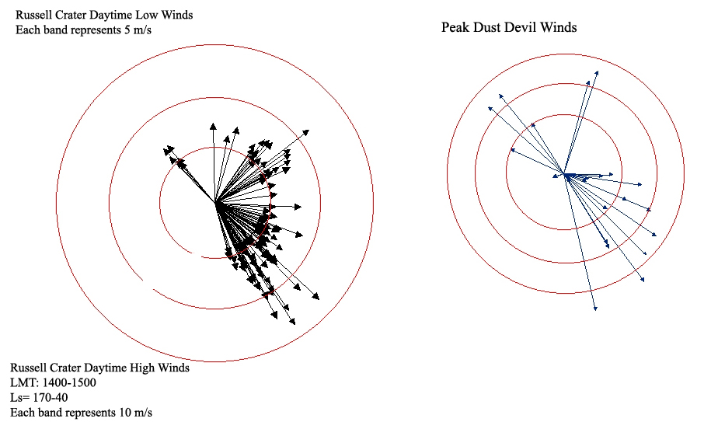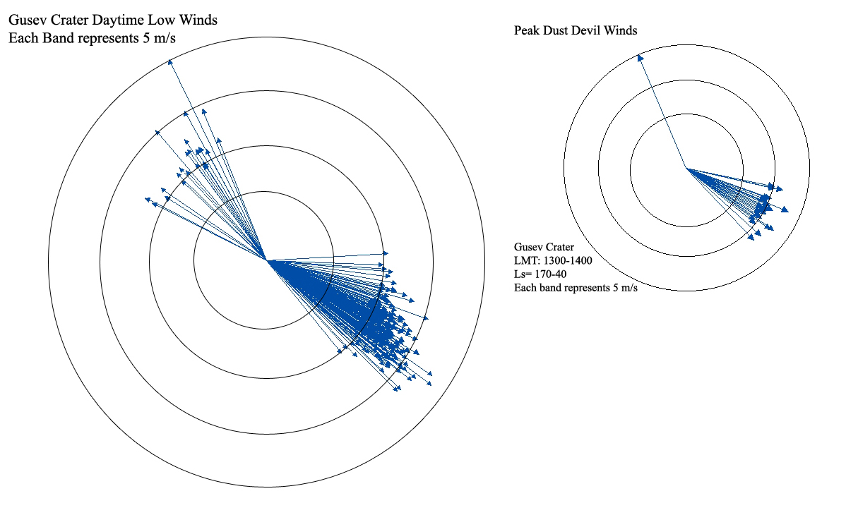Figure 12: GCM (model) predictions of wind orientations and strength in Gusev and Russell craters. The measured orientations of the dust devil tracks (in ArcMap) match well with the direction of the modeled peak lower atmospheric winds.

Dust devil season in the Columbia Hills region of Gusev crater (based on HiRISE observations) has a few remnant tracks from the previous season. There is an increase in activity until the 2007 dust storm displaces and redeposits dust. The dust devil activity briefly resumes and slowly decreases until the end of the season. The tracks gradually fade, but do not completely disappear into the winter months.
The dust devil activity can be seen in figure 13 which displays the fractional coverage in Gusev and Russell craters and reflects the active dust devil season. The dust devil season in Russell crater (based on HiRISE observations) starts with a complete absence of tracks as the dunes are covered in frost. Dust devil activity slowly increases as the frost sublimates away and the surface warms up. The tracks are concentrated in the frost-free zones. Dust devil activity increases until the dust storm erases the surface by wind streaks and covering tracks. After the dust storm, the activity restarts and increases until it reaches peak density, and then slowly decreases in activity until the region is covered in frost and dust carried and deposited by winter winds. There is no sign of any previous tracks once frost sublimates.
Measurements of dust devil track density as a function of season throughout one Martian year of HiRISE observations conclude that the dust devil season in Gusev crater is longer as indicated by the presence of tracks from L_{S} =139º to 90º as compared to that of Russell crater which extends from L_{S}= 172º to 40 º. However, the active season in Gusev is from L_{S}= 235º to L_{S} =~12º indicating the end of the major “active” dust devil season. The orbital observations indicate that the dust devil season in Gusev crater is longer than the season in which dust-devils have been spotted by MER Spirit observations (L_{S} = 160º - 340º) (Greeley et al., 2006). Peak dust devil frequencies occur sooner at Gusev (Spirit: L_{S} =250º; orbital data: L_{S} =235 º) than at Russell crater (L_{S} =316º).
Track densities during this time were stable and more consistent in Gusev crater and are more variable at Russell, particularly during the early part of the season. Russell crater has a higher density of tracks than Gusev crater. Both craters show bimodal seasonal densities because they were affected by the 2007 global dust storm which erased the tracks through redeposition of dust.
Russell crater tracks are curvilinear and moderately sinuous, with an average width of 38 m and lengths ranging from 340 m to 9 km. Russell crater tracks show an anticorrelation between dust devil track length and sinuosity (~1.3); the longer the track the lower the sinuosity. No other linear correlations were found. Gusev crater tracks are less sinuous (~1.08) and have an average width 56 m and lengths of 2-5 km. All morphological factors, lengths, widths, and sinuosity are seen in figures 14-16.

Figure 13: Density of dust devil tracks in each image in Gusev and Russell craters; used to determine the peak season and season length.

Figure 14: Lengths of tracks in each image of Gusev and Russell craters.

Figure 15: Widths of tracks in each image of Gusev and Russell craters. Note the difference between the scales of the widths. Gusev crater has a higher width than Russell crater.

Figure 16: Track sinuosity in each image of linear (~1.08) tracks in Gusev and curvilinear (~1.3) in Russell craters. Note the scale difference between the two craters. The sinuosity is calculated by taking the number of line segments (n) that make of the line and the distance of the line (d) and the line of the cumulative length of the line of all line segments (L) as D= log(n) + log (d/L).

MOC Observations
There are 15 MOC observations of Gusev crater (see tables 6/7) beginning in 2001 and ending in mid-2006, three months before the beginning of HiRISE observations. Because the images span five Earth years (2.5 Martian years), the MOC images are restricted in number but they allow monitoring of track erasure and confirm seasonal timing. These observations show that the tracks do not completely fade and have a higher track density per spatial area of ~50% until the 2005 dust storm. Between the dust storm and S1200095 (L_{S}= 316º) dust devils have a density of 1-2%. S1200095 is distorted and later images depict tracks gradually fading until PSP_003689_1650 when dust devil activity spikes. This gradual fading must be due to a higher airfall sedimentation that covers the tracks as the tracks nearly disappear altogether.
Russell crater has 10 MOC observations with sampling dominantly during late winter/early spring. Most of the images have no tracks and are frost covered. The images that do have tracks are consistent within the HiRISE season but the density is much lower. There are no distinguishable tracks in 2005 transitioning to HiRISE data.

Chapter 5

Interpretation
Formation of dust devil tracks
Temperature Correlation
Quantitatively, the morphological features of dust devil tracks are compared to the density, length and width of the tracks to seasonal temperature changes. I hypothesize that the dust devil season correlates with seasonal temperature variations as measured by the Thermal Emission Spectrometer (TES) over the Mars years 1999-2001. Surface and air temperatures were derived from TES data using the atmospheric algorithm component of Smith et al. (2000) and Smith (2004). The TES curves represent a general atmospheric temperature profile that is fairly representative of each crater location relative to pressure versus height. However, because the TES data were acquired in 1999-2001, they represents average climate, and do not include a global dust storm statistics. During a dust storm, the temperature profile at about L_{S}= ~270º-310º would show a dramatic drop in the temperature contrast and increase after the storm cleared.
Gusev crater
At Gusev crater, atmospheric temperatures were taken at pressures of 6.1 mb, 4.75 mb, 2.24 mb, 1.06 mb, 0.5 mb, and 0.11 mb and subtracted from the corresponding surface temperatures to create the temperature contrast profile as a function of the L_{S} season. Figures 17-20 display the profile plotted together with individual parameters (fractional coverage, length and width) to compare track characteristics to the seasonal temperature contrast. Figure 20 combines all factors together to demonstrate how all features compare to each other and temperature variations.
The scale height (the vertical distance over the pressure of the atmosphere) was calculated from the surface pressure (6.1 mb) to be ~13 km; the convective boundary layer height is estimated to be 4-6 km in low elevation regions (Hinson et al., 2008). Temperature contrast (at the boundary layer) ranges from 32 ºC to 57 ºC (early spring/late fall). The convection boundary layer is important as it controls the maximum height of dust devils. At Gusev, the tracks are wider and correlates with the shorter convective boundary layer height which indicates the vortices are shorter.
The temperature contrast (at 0.11 mb) during the highest density of activity (34% at L_{S}= 235º) is ~40 ºC which is below the maximum temperature contrast. The peak dust devil track densities and the peak widths occurred earlier than expected, before the hottest part of summer. The highest temperature contrast between the surface and the highest point in the atmosphere (at 0.11 mb) was ~120ºC at mid-summer, and the lowest contrast being ~30 ºC during winter.

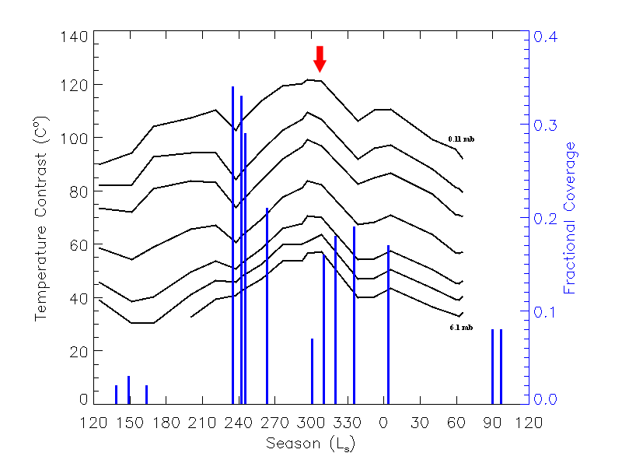Figure 17: Profile of fractional coverage (density) of dust devil tracks in Gusev crater compared to 1999-2001 TES measurements of the surface to atmosphere temperature contrast with season. Atmospheric temperatures at pressures of 6.1 mb, 4.75 mb, 2.24 mb, 1.06 mb, 0.5 mb, and 0.11 mb were used. The arrow represents the 2007 dust storm.

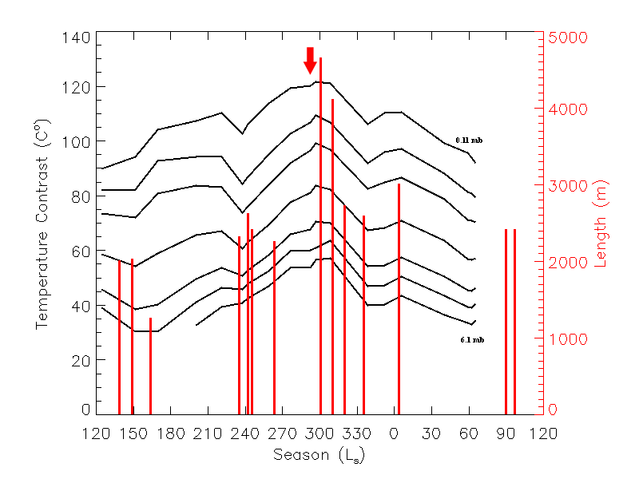Figure 18: Profile of dust devil track lengths in Gusev crater compared to the surface and atmospheric temperature contrast with season. The arrow represents the 2007 dust storm.

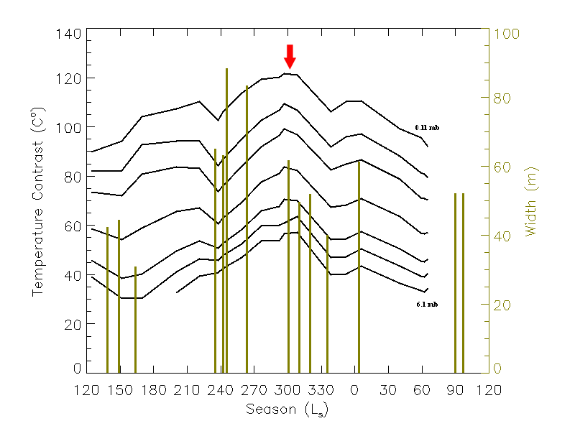Figure 19: Profile of dust devil track widths in Gusev crater compared to the surface and atmospheric temperature contrast with season. The arrow represents the 2007 dust storm.

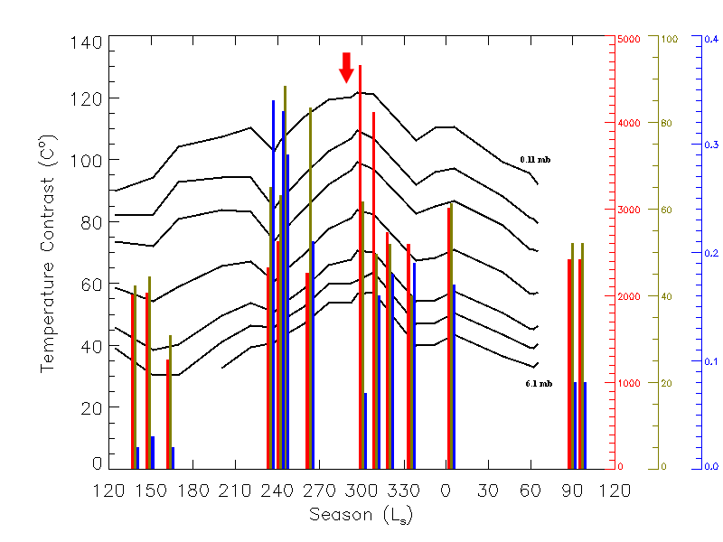
Figure 20: Profile of lengths (red), width (gold), and fractional coverage (blue) in Gusev crater compared to the surface and atmospheric temperature contrast with season. The arrow represents the 2007 dust storm.

Russell crater
Russell crater atmospheric temperatures were taken at pressures of 4.75 mb, 3.7 mb, 2.24 mb, 1.06 mb, 0.5 mb, and 0.11 mb and subtracted from the corresponding surface temperatures to create the temperature contrast profile as a function of the L_{S} season (figures 21-23). The compiled results (figure 24) of the fractional coverage, length, and width with the seasonal temperature contrasts show a direct correlation.
The convective boundary layer is estimated to be 8-10 km high at Russell crater because it is at a higher elevation (Hinson et al., 2008). The higher convective boundary layer at Russell correlates well with the smaller widths; these dust devils must reach higher into atmosphere due to the greater surface-atmospheric temperature contrast. The temperature contrast between the surface and the convection boundary layer (at 0.11 mb) ranges from 0.83 ºC (late winter/early spring) to ~45 ºC (summer). The peak track density at Russell (L_{S}=316º) takes place during a period of peak temperature contrast of 45 ºC which matches the prediction of dust devil formation between the greatest vertical temperature gradient. The highest temperature contrast between the surface and the upper atmosphere (0.11 mb) was ~118ºC at early summer, and the lowest being ~ -25 ºC during winter. At Russell there is a temperature inversion period where the surface temperature is colder than the atmospheric temperature, which is consistent with observations of surface frost. This thermal inversion prevents the formation of dust devils during the winter.

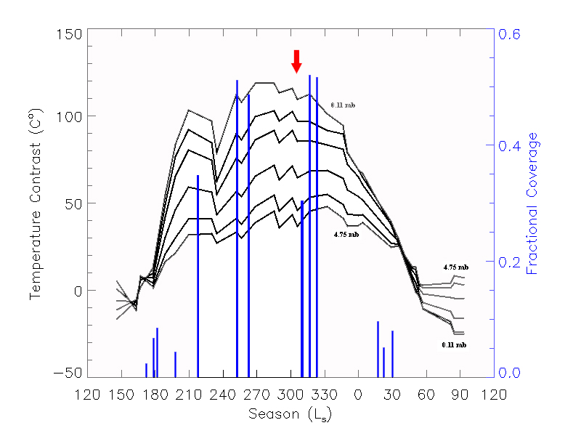
Figure 21: Profile of fractional coverage (density) in Russell crater compared to the surface and atmospheric temperature contrast with season. Atmospheric temperatures at pressures of 4.75 mb, 3.7 mb, 2.24 mb, 1.06 mb, 0.5 mb, and 0.11 mb were used. The arrow represents the 2007 dust storm.

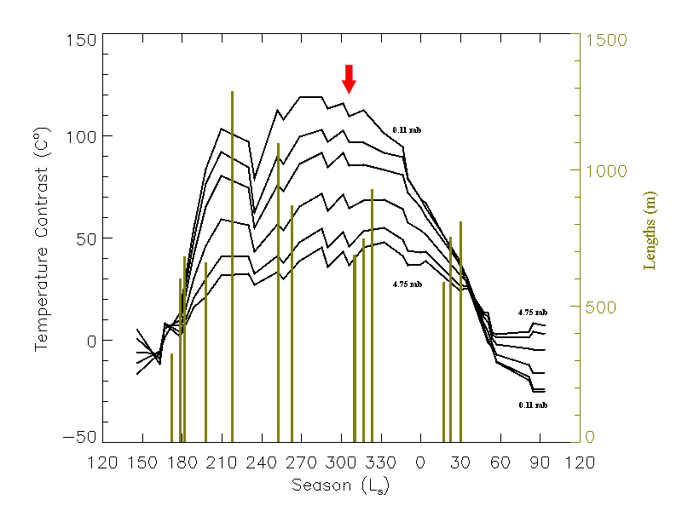
Figure 22: Profile of dust devil track lengths in Russell crater compared to the surface and atmospheric temperature contrast with season. The arrow represents the 2007 dust storm.

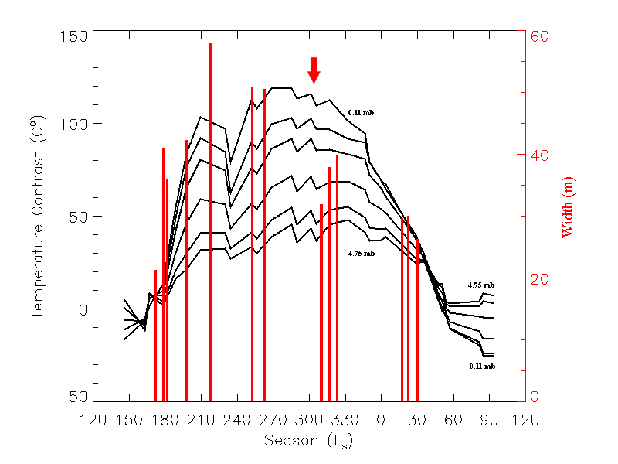
Figure 23: Profile of dust devil track widths in Russell crater compared to the surface and atmospheric temperature contrast with season. The arrow represents the 2007 dust storm.

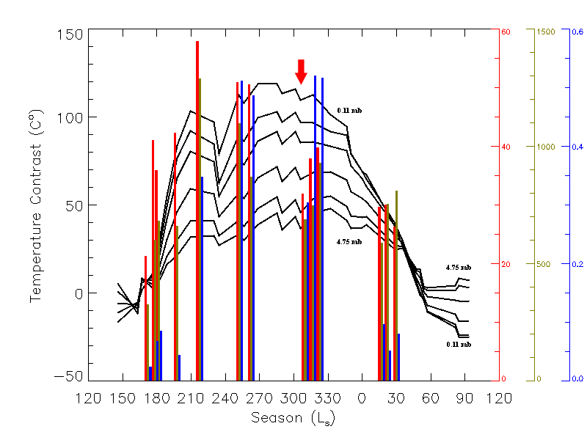Figure 24: Profile of lengths (gold), width (red), and fractional coverage (blue) in Russell crater compared to the surface and atmospheric temperature contrast with season. A temperature inversion during periods of CO₂ surface frost results in no dust devil activity. The arrow represents the 2007 dust storm.

Correlation Analysis
Comparison of the densities, lengths, and widths with atmospheric temperatures suggests that there is a seasonal temperature correlation. At Gusev crater, taking the dust storm into account, the temperature profile seems to match the increase and decrease of all these features. As the temperature contrasts increases, and as the season goes into spring and summer, the density, length, and width also increase. The time frame (seasonal L_{S}) affected by the dust storm is assumed to decrease in temperature, reducing the density, length, and width of the tracks. The factors increase with the slight temperature raise after the dust storm and all decrease again as the temperature gets cooler as the season moves into early winter.
At Russell crater the entire profile is similar to that seen in Gusev crater with the temperature contrast variations including the period when the dust storm occurs (L_{S}= ~300). During time periods of thermal inversion, when the surface temperature is lower than the temperature of the atmosphere, there is no dust devil activity or remnant tracks. The tracks are completely absent until the next dust devil season begins the following spring.
At both of the craters, track densities, lengths, and widths all correlate with seasonal temperature variations, resulting in increased dust devil activity.

Tangential Wind Velocity and Dust Devil Duration
The wind velocity and lifetime duration are also relevant to dust devil formation. The wind speed and the lifetime of a dust devil can be used to find the flux of dust lifted by dust devils, which contributes to the dust deposited on the surface. The individual dust devil flux can be used to compare to the atmospheric airfall and dust devil sedimentation rates, and how overprinting of dust devils influence erasure of older tracks.
The speed of the winds generated by dust devils is a balance between centripetal forces and the pressure gradient from inside the dust devil to the ambient atmospheric pressure. The tangential wind velocity of a dust devil can be expressed using the atmospheric gas constant (R), change of pressure in a dust devil (Δp), the surface pressure (p_{s}) and surface temperature (T_{s}) with the equation (Sinclair, 1966):
$Va≈\sqrt{\frac{\text{RT}sΔp}{ps}}$
A range of Δp was calculated from 20 data points compiled from ASI/MET Pathfinder data to be 0.011 mb (minimum), 0.0202 mb (average), 0.046 mb (maximum) of pressure that balances the centripetal forces inside of a dust devil (Renno et al., 2000). Based on these pressure changes, the tangential velocity is ~8-20 m/s.
This indicates that the dust devil pressure measured by ASI/MET Pathfinder data were of weaker dust devils if the modeled strongest dust devil results have pressure values of 50 Pa (0.5 mb) with a tangential speed of 60 m/s (Renno et al., 2000).
The lifetime of a dust devil is calculated by the length of the track divided by the ambient wind velocity. The ambient wind velocity is calculated by average wind vector parameters from the GCM to be 15 m/s (figure 14) compared to Spirit (11.2 m/s) (Waller, 2009). The minimum lifetime of a dust devil is 80 seconds, the average is 364 seconds, and the maximum duration is 1000 seconds.
Now that the lifetime of a dust devil has been calculated and the morphological factors of a dust devil are understood, this can be applied to how dust devil tracks are erased.

Erasure of dust devil tracks
The rate of erasure is a question that connects the surface and atmospheric processes: is the disappearance of tracks uniform or influenced by episodic events? Gusev crater is chosen for this specific analysis as the tracks fade gradually and are often still present in the next dust devil season the following year. Russell crater, on the other hand, has tracks that occur on a seasonal basis. Once winter winds come, other processes completely destroy and cover all tracks that do not appear the following season.
Through the use of modeling, I attempted to match the observed rate of dust devil track erasure with the rate of airfall sedimentation at Gusev crater constrained by global atmospheric opacity values, and the dust deposited by dust devils themselves. In order to determine the rate of erasure of the dust devil tracks, the dust accumulation depth must be calculated to determine if atmospheric airfall sedimentation or dust devils are enough to cover the tracks.
To determine the time and volume it takes to cover up a dust devil track, I started with the global atmospheric settling rate estimate of 2x10⁻² kg/m² of dust fall in one Earth year (Pollack et al., 1979). Dividing by the density of (3000 kg/m³) results in an accumulation rate of 6.67x10⁻⁶ m/year of atmospheric dust that falls on the surface. This is the equivalent of 6.67 microns in one Earth year (13.34 microns/Mars year); so in one season (90º), the amount of material that falls on the Martian surface is 3.34 microns/season. This number is the absolute maximum atmospheric accumulation rate which seems unrealistic for Gusev crater. Based on Mars Pathfinder, the solar panels showed an accumulation of dust of 0.28% of dust of ~10 g/m²/yr (Aharonson et al., 2003; Landis and Jenkins, 2000). This is equivalent to 0.01 kg/m²/yr or 3.33 x10⁻⁶ m/year (3.33 microns/year) of dust that fell on the surface of the solar panels. Aharonson et al. (2003) calculated a low net deposition rate of ~0.4 g/m²/year which equals a dust deposit of 1.33 x10⁻⁷ m/year (0.133 microns/year).
An upper limit to the rate of dust deposition is set by the amount of dust observed to be lifted by the dust devils. Using the dust-lifting rate of 19 kg/km²/sol estimated by Greeley et al. (2006) for Gusev, assuming that all of this dust settles locally, the dust depth can be determined by dividing the mass of material that falls onto the surface by the density of basalt. This gives a dust accumulation rate of 6.3 x10⁻⁹ m/sol (1.7x10⁻⁶ m/year) is equivalent to 1.7 microns/year from 50 dust devils/km²/sol over the 270 sols of the 2005 dust-devil season (Greeley et al., 2006). Greeley et al. (2006) explain the dust flux of a single dust devil (kg/s/area of dust devil) is total dust lifting rate of the region (kg/s/area of the region) assuming duration of 170 seconds and a dust devil radius of 6 m.
Spirit studies have shown that the dust devil lifting flux rate is 2.07 x10⁻⁵ kg/m²/s per dust devil from the previous year and in the current season of 1.89x10⁻⁵ kg/m²/s per dust devil (Waller, 2009; Greeley et al., 2006). The lifetime of a dust devil in 2004-2006 is 170 s and for 2004-2006 the duration is 128 s. The net deposition, assuming everything that is lifted is redeposited back to the surface, for 2004-2006 kg/m²/s is 1.7x10⁻⁶ m/year (which matches pervious calculated values), whereas 2006-2008 deposition is 8x10⁻⁷ m/year or 0.8 microns/year.
Next, to determine observational dust devil flux over its lifetime using the values of 1.89x10⁻⁵ kg/m²/s per dust devil for 153,000 dust devils in the area a sol equals 2.89 kg/m²/s (Waller, 2009; Greeley et al., 2006). The amount of material that is ejected onto the surface from one dust devil, during several lifetime values of 80 seconds, 364 seconds, and 1000 second, with an average radius size of 28 m (based on track width measurements).
With the measurement from observations assuming 3000 km² of an area in the low albedo pattern across Gusev crater (zone of dust devil activity) to get the dust loading parameters are as follow: 1) minimum value of 189 kg/km²/sol; 2) the average value of 863 kg/km²/sol; and 3) the maximum value 3.2x10³ kg/km²/sol. The upper limit of dust falling back onto the surface based on observational lifetime at 270 sols is 1) minimum: 17 microns/year; average: 78 microns/year; 3) maximum: 213 microns/year. Only a fraction of these estimated accumulated dust values would actually fall back onto the surface. The majority of the dust would stay in suspension in the atmosphere and be moved by winds in the convective boundary layer and become part of the atmospheric settling rate.
The widths of the tracks are much larger and lift more dust into the atmosphere than Spirit observations. This indicates that our assumption that the dust devil column width is the size of recorded observational widths is incorrect. However, the area of material that is picked up by a dust devil is larger than its core, probably due to the horizontal shear winds that feed the dust column.
Mapped tracks were also studied to see if there was an overlapping dust layer when a dust devil imprinted over a previous track. If the dust devils were directly throwing dust back onto the surface, one would expect to see a spectral change of brightness. Spatial analysis found that there is no overlying brightness tone on the edge of a dust devil track. This indicates that the dust floats back down once it has been uplifted in the vortex column to the convective boundary layer. This is important as it suggests that Martian dust devils do not have a dust skirt ample enough to create a boundary around the track edges.

Settling Rates Compared to Observational HiRISE erasure
Several HiRISE images at Gusev were examined to see how long it takes a dust devil track to disappear.

Image Pair | Ls (track lifetime)
PSP_001777_1650- PSP_003834_1650 | 93°
PSP_001513_1650- PSP_005034_1650 | 161°
PSP_005456_1650 - PSP_008963_1650 | 130°
PSP_005456_1650 - ESP_010097_1650/11943_1650 | 170° (min) | 248° (max)

Table 2: Erasure time scale for dust devil tracks seen in HiRISE image pairs.
Table 2 shows that specific dust devil tracks in Gusev crater were seen to persist from one HiRISE image to another. It was difficult to find tracks that were not overprinted by later tracks or erased by the dust storm. Thus the tracks observed were from before or after the dust storm. These tracks that were seen in later images appeared fainter until they were gone (either by overprinting or influenced by the dust storm).
It is estimated that the track depth is greater than 1 micron, with an upper limit up to 100 microns in depth (Michaels, 2006). An optically thick layer of dust that would effectively obscure the tracks at visible wavelengths would have to be 50-100 microns deep (Johnson et al., 2003). This is significant as it indicates that atmospheric settling rates are not high enough to cover the dust devil tracks each season in Gusev crater. This suggests that episodic events, such as the dust storm, are the dominant processes that completely cover the dust devil tracks. Another mechanism for erasure is overprinting by fresh dust devils that remove all dust in the surrounding area.
At Russell crater the main mechanisms for track erasure are surface frost, annual winter winds, and episodic dust storms. One factor that remains unknown in both Russell and Gusev craters is the role of saltation. Saltation plays a major role in aeolian systems and surface erosion. With the presence of the Russell dunes, there could be some level of mass transport.
Through brief examination of HiRISE observations, no major changes in secondary bedform ripples have so far been identified. However, there are a few bright features that could be underlying bedforms that may be covered and uncovered as the time goes on. Based on observations, the flux of sand must be low or confined to the specific area around the dunes. Also, some of the dust devil tracks fade incrementally which may be influenced by saltation of sand once the dust layer is removed by the dust devils.

Chapter 6
Discussion: Why are the two sites different?
Dust devil activity at Russell crater starts later in the season (mid-spring; L_{S}= 172º), has a later peak and ends in the late fall (L_{S}= 40º). The season begins much earlier at Gusev crater in early spring (L_{S}=139º) and reaches maximum activity in mid/late spring. Although the season at Gusev crater continues until L_{S}= 90º, there is very little addition of new tracks and old tracks do not fade as quickly as they do at Russell crater. Another factor to consider is that qualitative analysis of Gusev MOC images show the same tracks from the previous (2006) season and that a few small tracks appear but the true season does not start until the peak of the season (L_{S}=235º).
Hence the “true observational” season needs to be defined. The season is defined by the occurrence of significant activity that is not influenced by the tracks of the previous season and by tracks that are fading. This occurs between L_{S}= 235º-12º (total 137º) in Gusev whereas at Russell, the season occurs between L_{S}= 172º-40º (total 228º). Based on this conclusion, the observational season in Russell crater is longer than it is in Gusev crater.
Seasonal variations in dust devil activity are influenced by topography, sediment supply, and elevation, as well as latitudinal variations in the atmospheric dust cycle and local winds. Topographic features, such as the megadune field in Russell, enhance convective circulation due to surface heterogeneity, thereby playing a key role in dust devil formation (Souza et al., 2000). The greater the contrast between surface and air temperatures, the greater the surface heat flux and potential for dust devil activity (Sinclair, 1969; Renno et al., 1998; Greeley et al., 2006; Balme & Greeley, 2006).
Possible explanations for the differences in seasonal behavior between the study sites include: (1) average elevations up to 2000 m higher at Russell crater than at Gusev, resulting in enhanced convective circulation; (2) increased insolation at higher southern latitudes during perihelion when southern summer occurs; (3) frost on the dunes delaying the start of the dust devil season in Russell crater; and (4) topography of high transverse megadunes at Russell crater.

Elevations, Latitude, & Topography
There is an elevation difference of approximately 2000 m between the two craters based on MOLA data. Gusev crater is much lower in elevation whereas Russell crater is much higher. This difference in elevation changes the height of the convective boundary layer and influences the height and width of the vortices (discussed in the interpretation chapter). Gusev crater has a lower convective boundary layer and thus shorter and wider tracks. Russell crater on the other hand, is much higher so the convective boundary layer is also higher which results in a larger thermal difference and tall, narrow tracks are produced.
Mars is at perihelion during southern summer and therefore there is more direct sunlight (increased insolation) over Russell crater. The latitude difference delays the timing of dust devil onset and peak in Russell because of its southern mid-latitude location.
The biggest difference between the two craters is the presence of the megadune field in Russell crater and the absence of a dune field (but presence of ~60 m high Columbia Hills) in Gusev crater. Dust devils tracks tend to stop at the western slopes of Columbia Hills (highest peak at ~80 m), although dust devils traveled in topographic lows around the hill tops during periods of higher activity. These tracks were still visible throughout the season until the 2007 dust storm redeposited dust on the surface. At Russell crater there are tracks that travel up and down the gully slopes of 560 m as well as traveling perpendicular to the 400 m upper tier of transverse dunes.

Sediment supply
The topography of each location relates to the sediment supply and availability. Both craters show a change in dust coverage due to the 2007 dust storm when tracks were covered and dust devil activity decreased. Observations from Spirit’s Pancam showed the dust storm significantly altered dust devil production in Gusev. There was almost an immediate halt in dust devils imaged by MER Spirit's cameras as the measured atmospheric opacity (measured from Spirit) increased (Waller, D., personal communication 2009).
Spirit also spotted a dust devil that left no track in the HiRISE data. This indicates dust devils may form, but if there is not a sufficient amount of dust on the surface for the dust devil to pick up material as it moves forward on its path, it will leave no track. One explanation for the lack of a track is this was the end of the dust devil track season so the strength of the dust devil may have been substantially lower and thus it was incapable of picking up dust from the surface crust. Also, it is possible that the dust devil travelled a greater distance away from available sediment near Columbia Hills.

Influence of CO₂ frost
One question which this study was interested in addressing is the role of CO₂ surface frost in hiding or eliminating tracks in Russell crater. No previous tracks observed in MOC images (year 2005; L_{S}=89º), appear in the HiRISE image PSP_001440_1255 (3 months later; L_{S}=136º). However, image resolution and noise makes it difficult to determine if there are definite tracks. Image PSP_001440_1255 (L_{S}=136º) is completely covered in surface frost/ice and is dust mantled. Image PSP_001981_1255 (L_{S}= 157.704°) shows small curvy tracks appearing on the highest sunlit slopes. The dust devils do not travel on top of frost, instead the dust devils move around the frost.
There appears to be late frost and sublimation in MOC images (2001-2003) in comparison to HiRISE observations. There is frost (both CO₂ and H₂O confirmed by CRISM data; Gardin et al., 2009) on the south facing slopes of the gully alcoves and the lower tier of dunes in MOC images at L_{S}=205º (late spring) corresponding with low density of tracks. The seasonal density of the dust devils could be lower because the surface temperatures were cooler so the initiation of mass dust devil activity was subdued.
HiRISE observational analysis suggests that the tracks at Russell crater are covered with dust deposited by winter winds at the beginning of the end of the dust devil season. There are remnant tracks that have not been completely covered before CO₂ frost deposition completely stops the dust devil season. This change in track erasure does not appear to be a slow gradual process as the dust devils merely decrease in activity until activity ceases entirely due to the presence of frost.
Frost first appears on the gully alcove heads in PSP_7519_1255 (this denotes the end of the active dust devil season at L_{S}=40º) and all tracks have been completely covered or erased by L_{S}= 122º in PSP_009879_1255. This is a large time lapse between the two images from late fall to late winter so the rate of disappearance cannot be determined. The remnant tracks may not be visible through the dusty ice. However, when spring warms the surface and the surface is clear of CO₂ ice, there are no tracks present from pre-frost surface coverage.
If surface frost is not the dominant process in covering tracks perhaps Russell crater is influenced by atmospheric snowfall. Gradual sedimentation from atmospheric dust airfall appears to be a nonsignificant factor at Russell crater in covering dust devil tracks (see Interpretation for explanation). However, Mars’ atmosphere is dust-loaded and the dust particles act as nucleation sites for the CO₂ (and possibly H₂O) condensation. Therefore, I reason that it is possible that the CO₂ covered dust particles fall onto the surface and could be responsible for partially covering the surface and tracks. The CO₂ could sublimate from the particles leaving behind the dust which still covers the surface. This could explain why old tracks are completely covered and no old tracks are seen in observations the following warming season.

Cold Spot Activity
Initial Mariner 9 IRIS spectral studies by Forget et al., (1995) suggest regional areas of fresh deposits of CO₂ snow or condensation in the atmosphere with a signature of 10-50 μm. These results found that there was a correlation between regional dust storms and an increase in the number and intensity of “cold spots.” Cold spot activity is a result of fine grained CO₂ nucleation on the surface or near surface dependant on topography (e.g. in craters or polar slopes) (Titus et al., 2001).
A CO₂ cloud that has a particle radius larger than 10 μm is able to produce snow deposits which result in low brightness temperatures. The surface temperature and atmospheric temperature controls the deposition of snow. Forget et al. (1995) predicts that at 6 mb (near surface pressures) the CO₂ condensation temperature maximum is 148 K.
Mariner and Viking observed polar brightness temperatures that were well below the kinetic temperatures (140-148 K) for sublimation of CO₂ which has a spectral signature at ~20 μm (Kieffer et al., 1976a; 1976b). Thermal Emission Spectrometer (TES) was used to detect cold spot activity.
TES measured the total reflected and emitted radiation from the surface and atmosphere, which allowed measurements of the geographic variation of the net radiation balance through integration of the inferred condensation/sublimation rates and calculation of the annual solid CO₂ budget (Kieffer & Titus, 2000). The cold spot spectra were measured over the wavelength range 11.3- 25.2 μm (IRTM and TES data) where the CO₂ bands indicate the atmospheric temperature.
The Martian cold spot activity, measured primarily at temperature bands 18-25 μm, was compiled into several graphs based on points of latitude and season (Titus et al., 2001; Cornwall & Titus, 2009). Using TES data for Mars year 24 to Mars year 27 (Terrestrial time: 9 March 1999 to 3 September 2004) I have concluded that there is no temperature under 146 K (condensation temperature) at any atmospheric pressure (0.11-4.7 mb) or at scale height during any part of the season at Russell. Atmospheric temperatures at Russell crater are warmer, except at about ~L_{S}=45º the surface and atmospheric temperatures are nearly at the coldest equilibrium of about 153-159 K. Based on this analysis, CO₂ is not at condensation temperatures in the atmosphere to produce atmospheric snowfall. This does not rule out near surface fallout which could occur at the lowest surface and atmospheric temperatures.
Another factor to consider is that in the HiRISE observational data, the time scale is based on 2006-2009 (up to current observations) which includes a global dust storm image, PSP_005034_1650 (L_{S} ~300º). Dust storms increase the atmospheric temperatures and lower the surface temperatures. This could produce lower atmospheric snow storms; however, PSP_005034_1650 appears to have no snowfall on the surface.
Ruling out atmospheric snowfall can be compared to other TES analysis by Cornwall & Titus (2009) (figure 25) which shows cold spot presence based on latitude and season. There is no indication for cold spot activity (longitudinally) at Russell crater and the primary CO₂ presence is dominated by surficial CO₂ frost and ice.
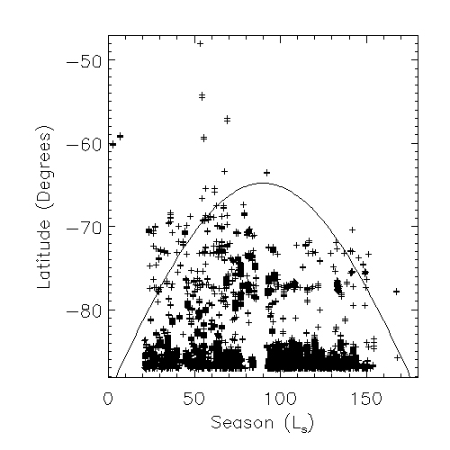
Figure 25: Cold spot activity (2003 TES data) profile based on season and latitude. There is no cold spot present at Russell crater (54ºS, 12.5ºE) although there is indication of cold spot activity nearby (crosses indicate cold spot activity, the majority of cold spots form within the polar night, represented by the solid line). Courtesy of Cornwall & Titus (2009).

Conclusions
Summary
Dust devils are cyclostrophic vortices that form when the solar heated surface air rises and is replaced by cooler air that flows radially inward into a convecting low-pressure core. The low pressure core of a dust devil acts a vacuum and lifts fine grained dust from the surface and exposes a trail of the basaltic subsurface. This exposure results in a positive feedback system as the darker surface creates a larger surface-atmospheric temperature contrast and thus, an increase of dust devil activity.
Terrestrial dust devils rarely leave tracks behind. Earth lacks the dust layer that the Martian surface has and the terrestrial surface is influenced by vegetation, fluvial erosion, and more complex regolith. Evidently by observations, Martian dust devils do not contain a dust skirt and there is no bright edge of material that lines the dark tracks.
The tracks in Gusev crater are longer, wider, and less sinuous than at Russell crater. Russell crater tracks reflect greater seasonal variations, have smaller widths and are more sinuous. The tracks follow the general wind trend predicted from the GCM, and their lengths indicated the local wind speed. As vortex-sustaining winds get stronger, the tracks get longer.
The presence of the ~560 meter high Russell megadune produces significant differences in dust devil morphology, including short, sinuous tracks. The interactions of dust devils with the megadunes suggest that dust devils prefer to climb hills, as predicted by theory. The smaller widths of tracks in Russell correlate with a lower convective boundary layer height. The annual surface frost controls the timing of the season and influences the morphology of the dust devil tracks in early spring.
The changes in morphology of the tracks (density, lengths, and widths) correspond to the seasonal temperature variations measured by TES. It was found that no tracks formed during times of thermal inversions at Russell crater. Temperature analysis, along with the morphology, supports the hypothesis that the seasonal dust devil peak, which occurs first at Gusev (L_{S}= 305º) and later Russell (L_{S}= 330º), coincides with the maximum temperature contrast between the surface and the lower atmosphere.
To understand the mechanism of the rate of dust devil track erasure, the rate of airfall sedimentation and dust displaced by the dust devils themselves were compared to a dust depth of 50-100 microns which is required to obscure the dark substrate and erase the tracks. Both the global sedimentation rate and the contribution of dust from dust devils were not high enough to cover the dust devil tracks each season (or match observational data). This indicates that other mechanisms, such as episodic erasure due to dust storms or annual changes are responsible for depositing dust over the tracks. Fresh dust devils also act as a mechanism of track erasure which destroys (overprints) previous tracks.
There are distinct differences between HiRISE observations and Spirit observations of dust devils in Gusev crater. 1) The track widths that are measured are larger than the diameter of the dust devil vortices measured by Spirit. This is an indication that the dust devil picks up more material along the edges of the vortex as a result of the convection inside the dust devil. The other possibility is that the tracks seen by HiRISE are made by larger dust devils than those that Spirit observes. 2) Spirit also only sees a small sample of dust devils each day, whereas HiRISE provides a record of all tracks that occur in a longer span of time. This explains why the season appears longer in orbital than surface observations. 3) HiRISE observational peak lengths and widths occur in the spring, whereas Spirit sees these peaks during the fall. 4) The average horizontal speed of a dust devil determined with HiRISE imagery based on the average duration observed by Spirit together with the average length of the track (~30 m/s), did not match the average speed monitored by Spirit (~11.2 m/s). Dust devil speeds could be greater than Spirit estimated, especially observing straight on from a 2-D scan while much of the dust devil motion was towards the rover. Additionally, the dust devils that produced tracks in HiRISE images may be longer an thus more likely to have a greater duration than those observed by Spirit.
Martian dust devils have been seen in Viking images, Mars Orbiter Camera (MOC) images, MRO’s Context Camera (CTX) and HiRISE. The HiRISE camera has provided very detailed resolution of ~25 cm/pixel; it is concluded that the benefit of HiRISE data for this study is the long time span of images, but the fine resolution was not required to determine the general direction of motion of dust devils.

Future Work
Higher resolution (mesoscale and microscale) models of local atmospheric circulations are essential for correctly comparing wind patterns, especially over the megadunes in Russell crater, instead of using a Global Circulation Model with relatively low spatial resolution. The observations from Russell crater will be compared to Mars Regional Atmospheric Modeling System (MRAMS) output. The MRAMS modeling will provide the directions of secondary winds, so that the influence of small surface winds that might drive dust devils over the dune crests and dissipate them can be investigated.
Other possible future work includes determining if there is H₂O snow that may influence the surface at Russell crater, since TES shows there is only the presence of CO₂ surface frost and no indication of CO₂ snow. CRISM data shows that there a presence of H₂O ice during the winter with the CO₂ in the gully alcoves and may have possible snowfall (Gardin et al., 2009). Another goal is to determine the scale of saltation that is taking place on the Russell dunes and general surfaces that could play a role in covering tracks.

References
Arvidson, R.E. and 23 others. (2004) Localization and physical properties experiments conducted by Spirit at Gusev crater. Science v. 305, p. 821–824.

Balme, M.R., and Greeley, R. (2006) Dust devils on Earth and Mars. Reviews of
Geophysics v. 44, RG3003, doi:10.1029/2005RG000188.

Balme, M.R., Whelley, P.L., Greeley, R. (2003) Mars; Dust devil track survey in Argyre Planitia and Hellas Basin. Journal of Geophysical Research v. 108, doi:10.1029/2003JE002096.

Barlow N. (2008) Mars: An introduction to its interior, surface and atmosphere. Cambridge University Press. ed. 1, p. 3.

Bell, J.F. III and 43 others. (2004) Pancam multispectral imaging results from the Spirit rover at Gusev crater. Science v. 305, p. 800–806.

Christensen, P.R. and 17 others. (2003) Morphology and composition of the surface of Mars: Mars Odyssey THEMIS results. Science v. 300, p. 2056-2062. doi:10.1126/science.1080885.

Cornwall, C., and T. N. Titus (2009), Spatial and temporal distributions of Martian north polar cold spots before, during, and after the global dust storm of 2001, J. Geophys. Res., 114, E02003, doi:10.1029/2008JE003243.

Edgett, K.S., and Malin M.C. (2000) Martian dust raising and surface albedo controls: thin, dark (and sometimes bright) streaks and dust devils in MGS high-resolution images. Lunar Planetary Sciences [CDROM] XXXI, Abstract # 1073.

Fisher, J., Richardson, M.I., Ewald, S.P., Tiogo, A. D., Wilson, R.J. (2005)
A survey of Martian dust devil activity using Mars Global Surveyor Mars Orbiter Camera images, Journal of Geophysical Research v. 110, E03004, doi:10.1029/2003JE002165,2005.

Gardin E., et al., (2009) Defrosting Sequence on the Russell Megadune, Mars. 40th Lunar and Planetary Science Conference. Abstract #2032

Geissler, P. (2005) Three decades of Martian surface changes, Journal of Geophysical Research v. 110, doi:10.1029/2005JE002345.

Greeley, R., and 13 others. (2006) Active dust devils in Gusev crater, Mars: Observations from the Mars Exploration Rover Spirit, Journal of Geophysical Research v. 111, E12S09, doi:10.1029/2006JE002743.

Greeley, R., Balme, M.,R. Iversen, J.D., Metzger, S., Mickelson, R., Phoreman, J., and White, B. (2003) Martian dust devils: Laboratory simulations of particle threshold, Journal of Geophysical Research v. 108, p. 5041, doi:10.1029/2002JE001987.

Greeley, R., Whelley, P.L., Neakrase, L.D. (2004) Martian dust devils: direction of movement inferred from their tracks. Geophysical Research Letters v. 31 L24702.

Hayward, R.K., Mullins, K.F., Fenton, L.K., Hare, T.M., Titus, T.N., Bourke, M.C., Colaprete, A., and Christensen, P.R. (2007) Mars Global Digital Dune Database: MC2 - MC29: U.S. Geological Survey Open-File Report 2007-1158. http://pubs.usgs.gov/of/2007/1158/].

Hansen, G., Control of the radiative behavior of the Martian polar caps by surface. (1999) CO2 ice: Evidence from Mars Global Surveyor measurements. Journal of Geophysical Research, 104, 16,471- 16,486.

Hinson, D.P. Patzold, M., Tellmann, B., & Tyler, G. (2008) The depth of the covective boundary layer on Mars. Icarus. V. 198. 1. pp. 57-66.

Johnson, J. R., W. M. Grundy, and M. T. Lemmon. (2003) Dust deposition at the Mars Pathfinder landing site: Observations and modeling of the visible/near-infrared spectra, Icarus, 163, 330– 346.

Kieffer, H. H., S. C. Chase, E. D. Miner, F. D. Palluconi, G. Munch, G. Neugebauer, and T. Z. Martin. (1976) Infrared thermal mapping of the Martian surface and atmosphere: First results. Science, 193, 780–786.

Kieffer, H. H., P. R. Christensen, T. Z. Martin, E. D. Miner, and F. D. Palluconi. (1976b) Infrared thermal mapping of the Martian surface and atmosphere: Viking observation of diurnal and geometric observation, Science, 194, 1346–1351.

Kieffer, H. H., T. N. Titus, K. F. Mullins, and P. Christensen (2000) Mars south polar spring and summer behavior observed by TES: Seasonal cap evolution controlled by frost grain size. Journal of Geophysical Research, 105, 9653-9699.

Kossacki, J.K., Kopystynski, L. (2004) Non-uniform seasonal defrosting of subpolar dune filed on Mars. Icarus v. 168, p. 201-204.

Malin, M.C., and Edgett, K.S. (2001) Mars Global Surveyor Mars Orbiter Camera:
Interplanetary cruise through primary mission. Journal of Geophysical Research v. 106, p. 23,429-23,570.

Mattson, S. (2008) HiRISE DEM calibration of Russell crater.

Newman, C.E., Lewis, S.R., Read, P.L. and Forget, F. (2002) Modeling the
Martian dust cycle: Representations of dust transport processes. Journal of Geophysical Research v. 107, 5123, doi:10.1029/2002JE001910.

Reiss, D. and Jaumann, R. (2002a) Spring defrosting in the Russell Crater dune field- Recent surface runoff within the last Martian year? Lunar Planetary Science XXXIII, Abstract #2013.

Reiss, D., Jaumann, R. (2002b) EGS XXVII General Assembly, Nice, 21-26 April 2002, abstract #4529.

Renno, N.O., Burkett, M.L., Larkin, M.P. (1998) A simple thermodynamical theory for dust devils. Journal of the Atmospheric Sciences v. 55, p. 3244-3252.

Sinclair, P.C. (1969) General characteristics of dust devils. Journal of Applied Meteorology v. 8, p. 32-45.

Smith, M.D., Bandfield, J.L., Christensen, P.R., 2000. Separation of atmospheric
and surface spectral features in Mars Global Surveyor Thermal Emission Spectrometer (TES) spectra. J. Geophys. Res. 105, 9589–9608.

Smith M.D. (2004) Interannual variability in TES atmospheric observations of Mars during 1999-2003 Icarus, 167 (1), pp. 148-165.
Souza, E.P, N.O. Renno, and M.A.F. Silva Dias (2000), Convective circulations induced by surface heterogeneities, J. Atmos. Sci., 57, 2915-2922.

Titus, TN., Kieffer, HH., Mullin, KF. (2001) TES premapping data: Slab ice and snow flurries in the Martian north polar night. Journal of Geophysical Research. 106. 23,181-22,196.

Thomas, P., and Gierasch, P.J. (1985) Dust devils on Mars. Science v. 230,
p.175-177.

Table Appendix
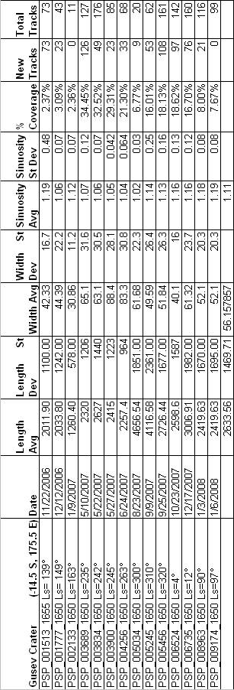

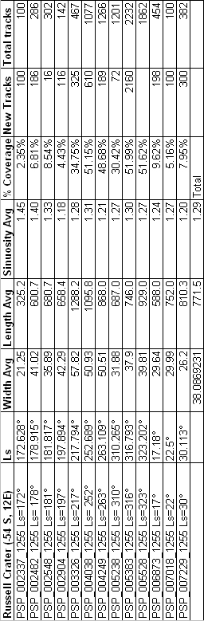

MOC: Gusev crater | Date | Ls | Notes
E0300012 | Apr-01 | 139 | Lack of dust. Track estimate ~5%
E1601962 | May-02 | 18.77 | Entire Columbia Hills region: High density ~ 50-60% (SE dominant direction) Lower CH region dark albdeo (lack of dust) New tracks from E0300012
R0200357 | Feb-03 | 134.1 | Entire Columbia Hills region: High density ~ 50-60% (SE dominant direction) Lower CH region dark albdeo (lack of dust) Rough guess of very few tracks from previous image
R0802402 | Aug-03 | 249.2 | Upper Columbia Hills region: track estimate ~50% (SE direction with some to NE)
R1301467 | Jan-04 | 331 | Small image zoomed to west of Columbia Hills; estimate 30%
R2001024 | Aug-04 | 75.9 | Lots of tracks sw direction. Track estimate ~ 50% and fading
S0200972 | Jan-05 | 149.2 | Middle left Columbia Hills: Longer tracks from w/nw transverse to CH
S0800891 | Jul-05 | 245.6 | Missing data: darker albedo, wind streaks; very faded tracks. In between 2005 dust storm.
S0802718 | Jul-05 | 256 | Dark albedo around entire Columbia Hills; some distinct tracks to SE. Wind blown material (to NW)
S0902527 | Aug-05 | 275 | Dark albedo around entire Columbia Hills; some distinct tracks to SE. Wind blown material (to NW) and a few tracks from previous image gone
S1200095 | Nov-05 | 316 | distorted; no tracks
S1800976 | May-06 | 51.8 | Lower right of Columbia Hills, track estimate ~2% Tracks transverse from smaller craters
S2000248 | Jul-06 | 74.7 | Close up of Columbia Hills, very light tracks (fading?) ~1%
S2000860 | Jul-06 | 78 | distorted
S2100323 | Aug-06 | 89.2 | Close up of Columbia Hills, very light tracks (fading?) <1%

MOC: Russell Crater | Date | Ls | Notes
E0201493 | 3/1/2001 | 132 | No tracks; image is cut off. Bright slope streaks/avalanching?
E0300976 | 4/1/2001 | 143.9 | No tracks
E0400835 | 5/1/2001 | 160 | No tracks; frost, CO₂ sublimation, dark slope streaks
E0200881 | 2/1/2003 | 138.9 | No tracks, High albedo feature on dune (illumination or frost) South facing slopes have some sublimation appearance
R0200996 | 2/1/2003 | 139.9 | No tracks
R0601007 | 6/1/2003 | 205 | Track estimate: 5% High albedo feature on the south facing slopes (frost in summer!) with no preference to where tracks form
R1301912 | 1/1/2004 | 332 | Track estimates 15% On upper tier and gully slope, lower tier dunes only along ridges. Some distinguished scallops prefer crests/dark dunes.
R1801512 | 6/1/2004 | 49 | Track estimate 5-10% Tracks mostly along NW slip face. Possible frost along gullies.
S0300120 | 2/1/2005 | 154.2 | No tracks
S0702672 | 6/1/2005 | 236 | Can see image but distorted, minor tracks?

